SIS # SEP 16 # 01

Message from the Resident Director
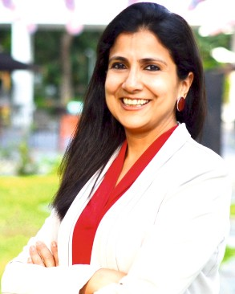
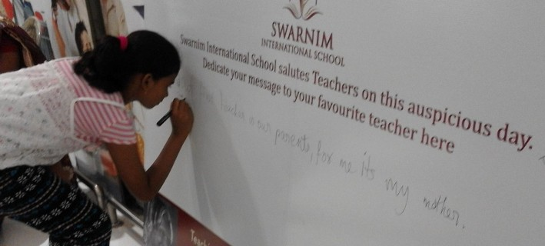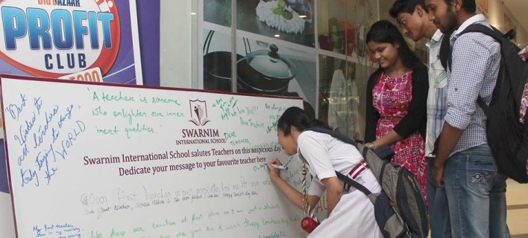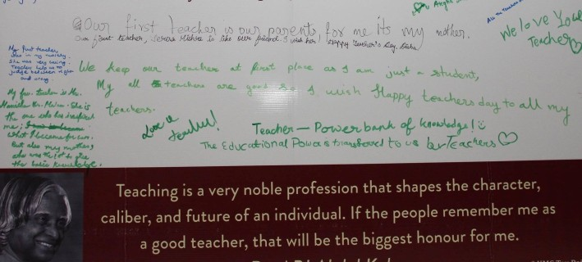Swati Sarawagi
Welcome to our first newsletter.
Thank you for choosing Swarnim as the school for your child. Choosing a good school is a very difficult decision and we thank you for your faith in us.
We, at Swarnim, are excited at the growth of the school. There are new additions to the infrastructure almost every week – be it books, sports
equipment or pets. However, what really makes the hallways come alive is the children's energy and enthusiasm for learning. We realize that some children are joining school for the first time. Some face challenges with English as the medium of instruction. Some children are not ready for socialization. It is our mission to help every child feel welcome, connected and part of the Swarnim family.
At Swarnim, we have great teachers who spend hours creating and planning activities to keep your child engaged. We strive to make each child feel comfortable, yet stretch them beyond their comfort zone.
We hope you find our website helpful. Please feel free to contact me with any concerns at
director@swarniminternational.in
Once again, welcome to the Swarnim family. Let us embark on a journey where your child's
love for learning will always grow.

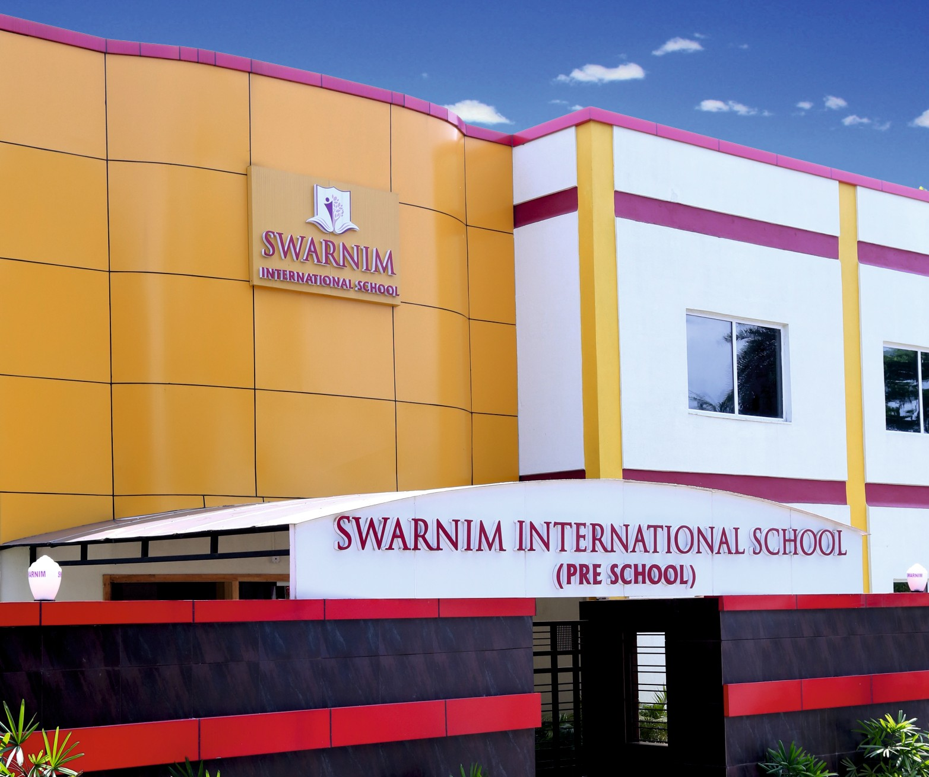

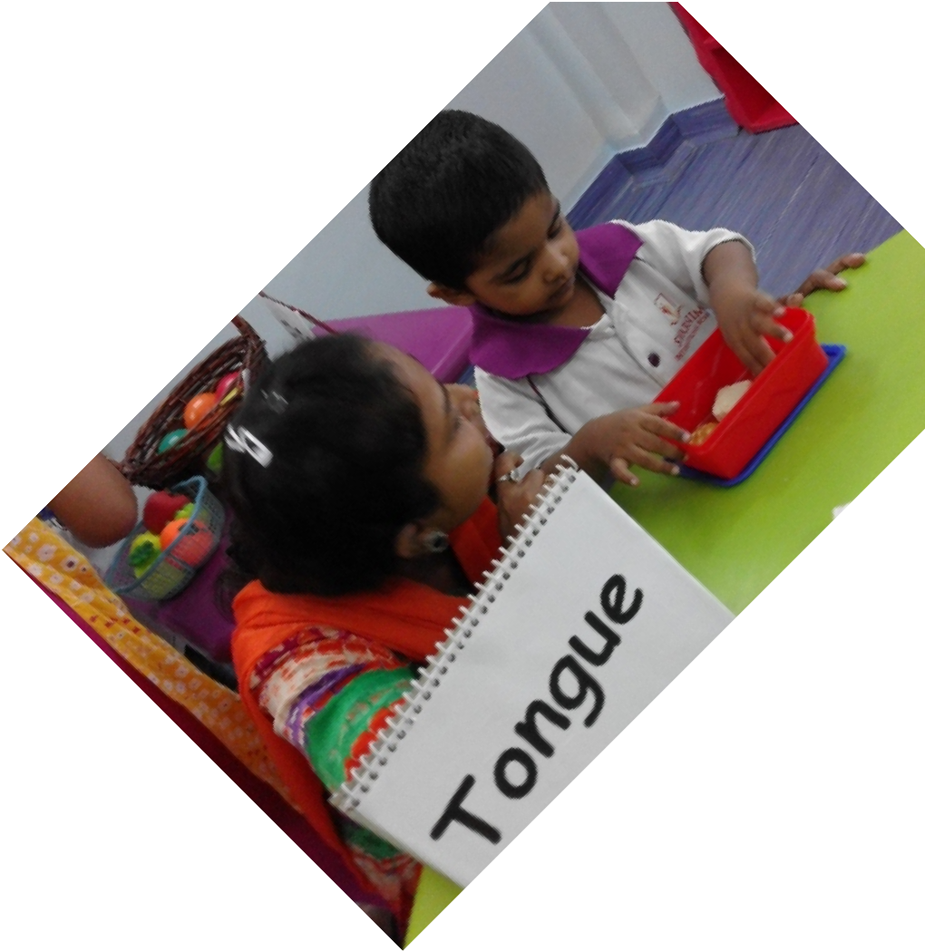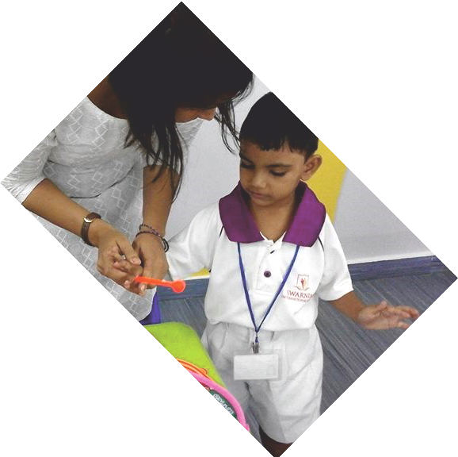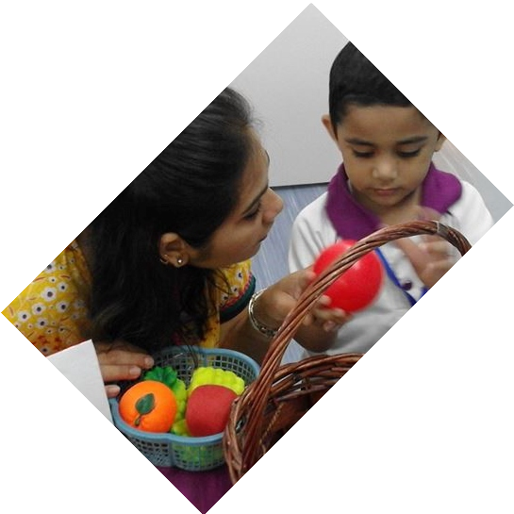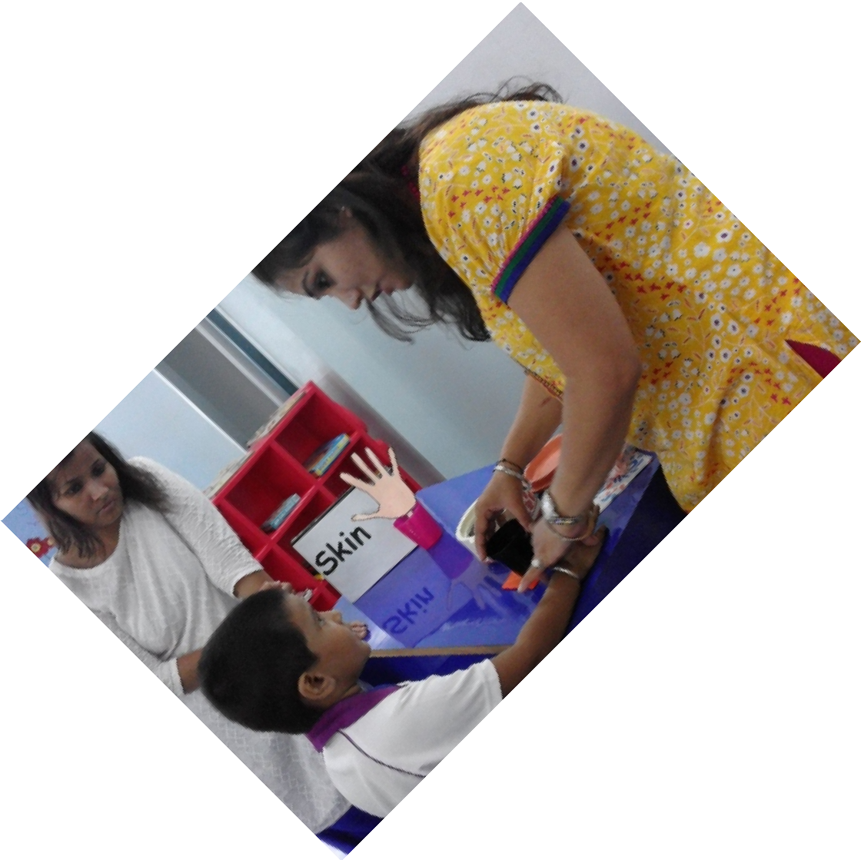 SPECIAL ACTIVITIES & OCCASIONS

SENSE STATION:
This innovative activity tickled the senses of all! Five stations related to the five senses were placed in the classroom. Each child stopped at a station and identified the sense organand the sensation associated with it. For example, at the Ear Station, there were drums, xylophone and a bell. Children shut their eyes and identified the instrument by the sound they could hear.
Others were Eye Station with colored balls, Tongue Station with a sweet and a savoury and the Skin Station with rough and smooth surfaces.

FATHER’S DAY:
The students used finger painting technique to make cardboard pen stands to celebrate Fathers Day They carried their creations with immense care and pride.

INTERNATIONAL YOGA DAY:
On 21st June, as the world celebrated International Yoga Day, our toddlers were introduced to their first yoga steps. The steps for beginners included Volcano, Lion and Downward Dog. Needless to say the children looked very cute trying to copy their teacher's poses.

PARENT ORIENTATION:
A collaborative effort of the parents and school is essential to maximize a child's potential. Two new parents orientation programmes were conducted in the school – on 28th April and 13th June.

LET’S WORK TOGETHER TO MAXIMIZE OUR CHILDREN’S POTENTIAL

Parents were briefed on the following points:

Changing needs and the changing face of education Skills of the 21st Century
Theme Based Learning Our Approach to Teaching Role of Parents

SCHOOL PROGRAMME OVERVIEW WORKSHOP:

School representatives attended the workshop organized and conducted by the British Council on 8th August at DPS Megacity School.

The workshop emphasized the 6 core skills - critical thinking& problem solving, digital literacy, student leadership & personal development, communication & collaboration, creativity & imagination and citizenship. Few group activities demonstrated innovative methods of teaching in a class.

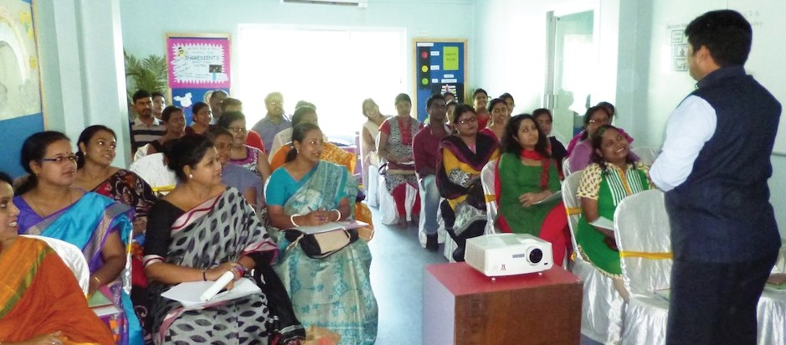

PRINCIPAL'S CONCLAVE:
The Headmistress attended the Principals' Conclave organized by The Heritage School on 24th June 2016 which was followed by a panel discussion on the topic “Knowledge without integrity is dangerous and dreadful” – Samuel Johnson.

Dr. Achyuta Samanta, Founder & Mentor, KIIT University, Bhubaneswar and Ms. Shabnam Ramaswamy, Founder, Jagriti Public School / Street Survivors India were the keynote speakers. The session was enlightening.

FORMATIVE APPROACH OF TEACHING & LESSON PLANNING:
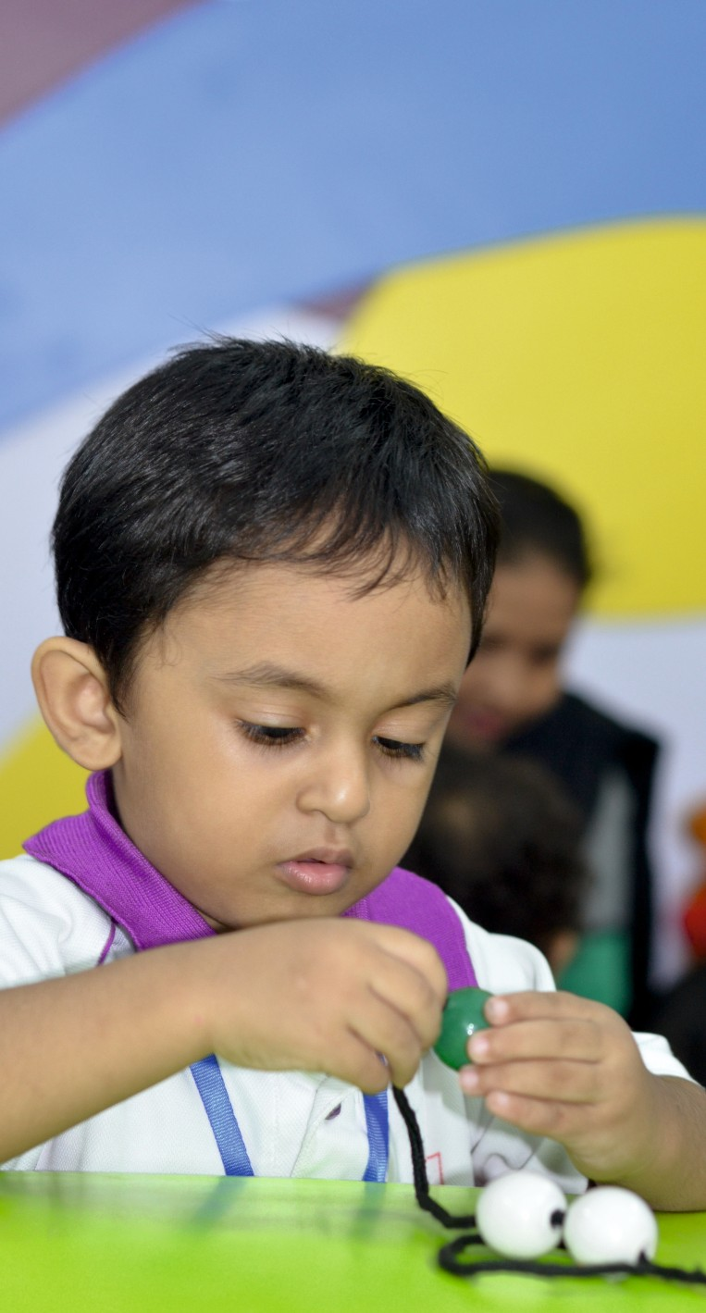
On 23rd April, Mr. Amitabh Mohan conducted a workshop for our teachers. Our teachers were trained on the importance of lesson plan, how it helps in planned teaching and how to have SMART learning objectives to make effective lesson plans.
SMART is the acronym for Specific, Measurable, Attainable, Realistic and Time-bound. The main emphasis was on learning objectives using the context of levels of learning from Bloom's Taxonomy.

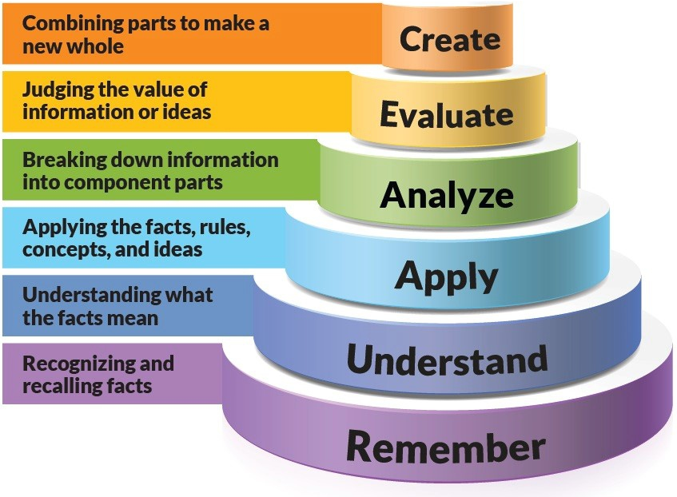
ORIGINAL BLOOM’S TAXONOMY

These tiers were used as building blocks to help teachers scaffold their lessons and build students up to the top tier of thinking.

Message from the Headmistress
Rumjhumi Biswas
There are many considerations in selecting a school for a child. Among many, one of the major criteria is the medium of instruction. When parents choose English medium schools for their children, it means that they realize the importance of English as the language of communication, collaboration and connection in the 21st century. They also believe that a child will be proficient and fluent in a language if it is learnt from an early age. It is not only important from a global perspective to know how to read, write and speak English, but it is equally essential in a pluralistic society like ours too. There is a counter argument, that it is very important to learn the mother tongue
and it is difficult for a child to learn more than one language. I would like share my experience and observations as an ESOL (English for
Speakers of Other Languages) teacher for many years.
We can be rest assured that our child's little brain can cope with two languages or more without affecting the dominant language. This has been well proven by decades of research and countless families around the world. But the focal point of my discussion today is how effortlessly our children can pick up English even if that language is not spoken at home.
A child acquires a language by listening to it. If you speak Bengali at home, a child automatically starts speaking the language as he grows up. Who taught him? The environment and his urge to communicate his wants and needs. So when we expect him to pick up another language, English in this case, we must provide him an “environment” where he listens to English and it is imperative to communicate in English too. It is neither practical nor desirable that everyone starts speaking and interacting in English at home. The child gets such an environment in school.
There are four components of language learning – listening, speaking, reading and writing. Each of these skills has to be developed for learning any language. But, often we neglect the most important and the foremost component –“listening”. Our curriculum and assessment cater to all these four areas. At school the child listens to the teachers' instructions in English and hears the staff speaking the language among themselves. This conducive environment helps the child get acquainted to the new language and he gradually builds up a vocabulary for basic communication.
Besides school inputs, very simple method to improve fluency among children is loud reading. A child who can read must be encouraged to read their texts aloud at times. When a child reads aloud, he is 'looking' at the words, 'pronouncing' the words and also 'listening' to his own voice. Simultaneously, three senses are being used and it is a very effective method of oral drilling. For preschoolers, parents can read out stories to them.
Studies have concluded that learning two languages simultaneously is easier for the child. Sometimes the child will mix both languages, but it is both harmless and temporary. As the child increases his vocabulary in each language, this phenomenon automatically disappears. Children can be encouraged to watch television programmes which are telecast in English, even if it is their favourite cartoon show, though parents must limit a child's television watching time.
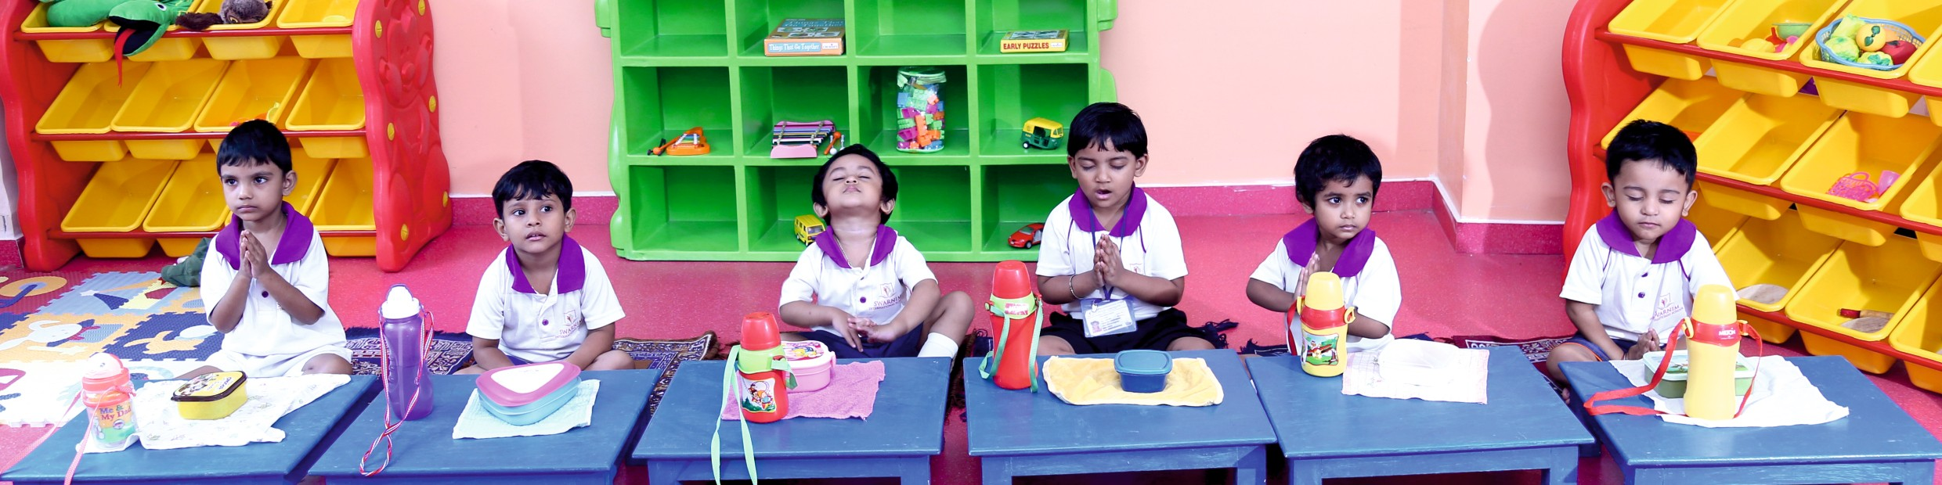
English Language Teaching is one of our priorities and with parents' cooperation we aspire to achieve a lot.

