How Saying “NO” Affect Kids #YesMom Vs. Mom SA
Source: Priya Sachan, Parenting Blogger, Founder & Chief Editor, ShishuWorld
How saying NO affects kids – The other day I was looking at a video shared by a mom in our Mommy group. The video was in short emphasizing the need for mums to be strict and telling kids their limits for their own good. It said that children of strict mothers turn out to be more successful than children of those who are supposed to be lenient. This got me thinking, “Am I a strict mother”? I realized that while I do believe in setting limits and letting children know that they cannot get away with everything, I do not say ‘NO’ to most things. I believe in saying ‘YES’ more often than not.
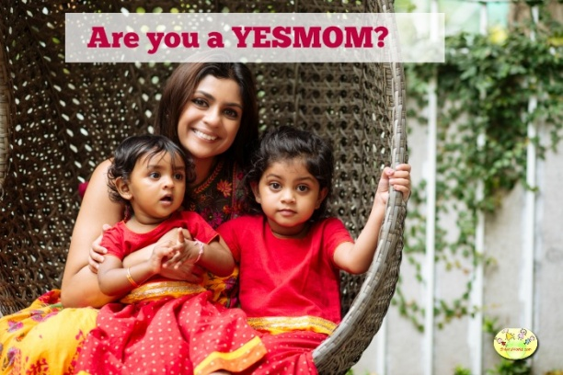
So, I was discussing this with my friend and she said that I am a gentle parent. Perhaps I am or MAYBE NOT! I certainly believe that there should be limits to everything and I tell my child categorically when I feel she is doing something wrong or if I feel something could be dangerous for her. But I still say YES to a lot of day to day stuff.
So, when I saw this video about how kids can get affected when we stop them from doing simple things, it reinforced my beliefs about not saying NO to most things. And yes! I have been judged for being #YESMom. I have received sideward glances because I let my daughter hang upside down on the monkey bars, or when I let her play in the sand or even climb a tree or jump in puddles left after the rain.
I also feel most requests that you want to say NO to can be turned into YES with a simple tweak. So, if my daughter wants her favourite chocolate, I say Yes, we can have it once a month. If she wants to watch a particular TV program, she has to let go of something else, because she knows too much of TV is bad for her. I try not to say ‘NO’ outright, unless it is something which might be dangerous for her like once she wanted to make an ‘omlette’ all by herself including frying. We bargained on breaking the egg, mixing the seasoning and beating, even putting the egg in cold frying pan, but I took over after that while she watched.
So here are my reasons for being a “YESMom”.
- Effects on children when you say “YES” more often.
- Children learn to explore their surroundings without fear.

- Children have more self confidence because they know parents trust their judgement.

- Children do not miss out on life experiences with friends. One of my favourite memories of school time is how my friends and I used to walk back from school jumping in puddles after rain. It is a priceless memory and never fails to bring a smile back to my face. I do not want my daughter to look back at her childhood with regret that she never jumped in puddles or climbed a tree. These experiences are worth much more than a bruised knee or wet shoes.
- Children learn their own limits after making mistakes and learning from them.

- The biggest life lesson that they perhaps learn is that it is OK to take risks and make mistakes.

- It also teaches them that it is alright to fail and try again if you are not able to achieve something in the first attempt. In our zeal to protect them, we end up giving them a message that they must follow instructions that we give and be successful at everything.

