Child Friendly Holiday Destinations in India in 2021
Source: Debashree Chakraborty, Travel Blogger
India is full of excitements for travelers. Children especially find the country a treasure box. Child friendly holiday destinations in India are available in abundance, offering amazing experiences. Traveling with kids to India is one of the most eye-opening trips. The days spent here are like living in a storybook where each page has its own fairytale. Furthermore, there are a number of places, monuments, cultures and things to do on your family holiday in India. Since the country is vast, we list down the best places to plan a family vacation with kids.
Here are some of the top child friendly holiday destinations in India in 2021.

JAIPUR
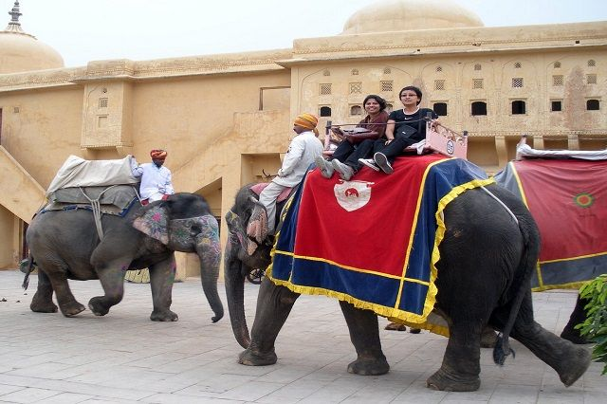
Jaipur is a fun-filled holiday destination. Visiting with family along with children is definitely a great idea. While the beautiful Pink City is full of history and culture, there are also exciting experiences. The city is a learning experience, as ancient structures spark their imagination and love for history. For one thing, there are a lot of interesting things to do for children of all ages. Have fun riding on elephants or camels, it is definitely the best. In addition, here are also special places to play, interact as well as paint the gentle beasts. For a village fair kind of experience, visit the Chokhi Dhani. Furthermore, teenagers will find the astronomical instruments at Jantar Mantar absolutely fascinating. In addition, the Jaipur Zoo is also an entertaining hangout.
Things to do in Jaipur with children:
Elephant ride, village feel in ‘Chokhi Dhani’, Trekking to Amer Fort, explore Hawa Mahal, Jal Mahal, Jantar Market, ancient temples and even the chaotic markets.

MUNNAR
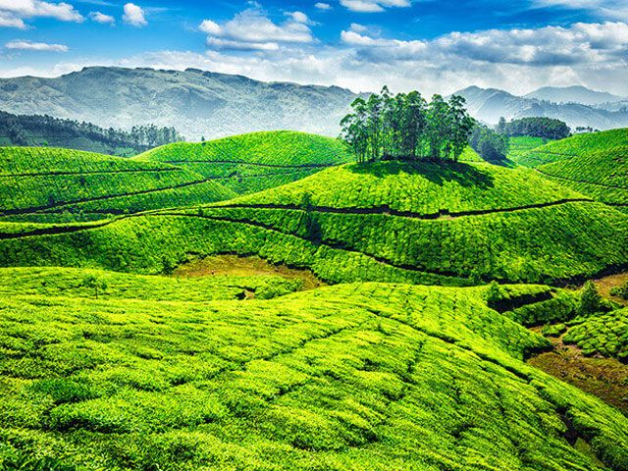
The hills excite families for a vacation unlike any other. The hill station in Western Ghats, Munnar is ideal for family vacations with children. While the natural beauty is perfect, the hill town has been a favorite of honeymoon couples mostly. However, the town welcomes families likewise. The kids will love to wander around tea plantations and learn about tea extraction process. The pleasant climate is one of the factors to take your kids along. Above all, the mountain air is cleaner and so much fresher than choked up cities. For adventure, take children for soft trekking on hills or go and visit wild sanctuaries around Munnar. Make sure you definitely visit the tea museum with your kids, to learn about the process involved in brewing tea.
Things to do in Munnar with children:
Trekking, boating, elephant rides, paragliding, tea plantation tour, museum visits, stay in tree houses, etc.
Best Time to Visit Munnar: September to May.

GOA
The abundant things to do in Goa make it a popular holiday destination to visit with kids. Children will never have a dull moment on holiday here. Beach-side destinations are a favorite with people of all ages including the kids. Wouldn’t they love building castles in the sand or frolicking in the water? For the adventurous there are many water activities, swimming, jet ski, parasailing, banana rides and much more. When you have had your fill of the beaches, explore the sightseeing opportunities ranging from churches, old forts, to interesting museums, spice plantations, waterfalls and wildlife sanctuaries. Create cherished memories for holidays in India with children.

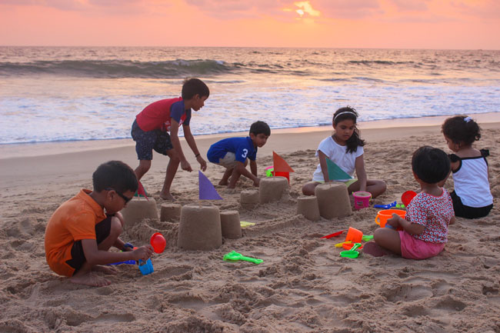

Things to do in Goa with children:
Spend the day on shores; take them to wildlife sanctuaries, old forts, museums, elephant rides and bathing in the spice plantations.

MC-LEODGANJ

Though the first impression of McLeodganj is that it is a popular place for grownups, children can also have a great vacation in the hill town. The quiet town in Himachal Pradesh is the abode of Dalai Lama and many Tibetans in exile, children can learn a lot about Tibet, the culture, history and a lot more from them. The monasteries are exciting to explore. The markets offer delicious treats. There are simple trekking trails, adventure camps and homestays where families can enjoy a fun time. Holiday in Mcleodganj is a good step to develop maturity in the personality of children. Escape the heat and hustle –bustle of cities, Mcleodganj is one of the best places to visit in June in India.

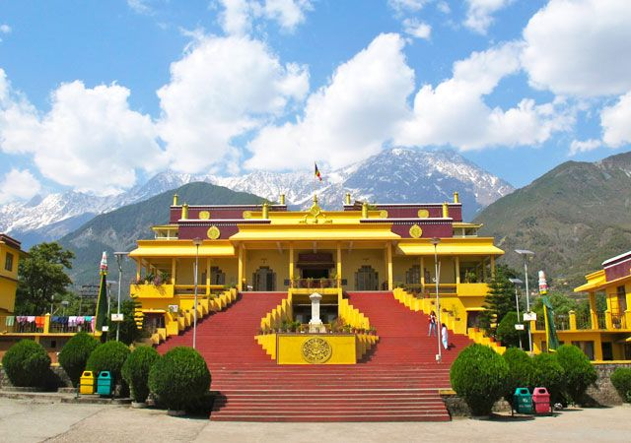
Things to do with children in McLeodganj: Explore monasteries
Best Time to Visit: Throughout the year with exception of the monsoon season.

MUSSOURIE

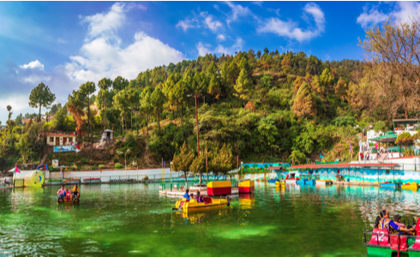

The Queen of Hills, Mussoorie is one of India’s top child friendly holiday destinations. Settled in the heart of lush greenery the town is perfect to escape the cities and spend time in the heart of nature. Families can enjoy the beautiful surroundings. The excitements of your holiday include cable car ride from the Mall to Gun Hill. Explore Jhari Pani Falls, Bhatta Falls, Lake Mist, Mussoorie Lake, Company Garden, Camel’s Back Road, Lal Tibba, and the Sir George Everest. Lastly, you can also visit Mussoorie resident Ruskin Bond, one of the most beloved writers of children’s literature in India.

Things to do with children in Mussoorie:
Soft trekking, cable car rides, bathing in waterfalls, picnic, horse ride, boating, etc.

Best Time to Visit: Throughout the Year.

DARJEELING
Traveling on a toy train huffing and puffing steam chugging through the mountains does it not sound a dream come true? Darjeeling makes this dream come true. The hill station in West Bengal is one of the best vacation spots in India to go with children. Kids enjoy the scenic Rail-ride from New Jalpaiguri to Darjeeling (almost a 70 km stretch). The other charm is the lush tea gardens where you can learn about the magical brew. Let them run through the gardens, playing hide and seek. Other attractions are the Padmaja Naidu Himalayan Zoological Park, waterfalls and cable car ride which will be a thrilling experience.

Things to do in Darjeeling with children:
- Ride the Darjeeling Toy Train, also a UNESCO World Heritage Site with an interesting history
- Enjoy cable car ride
- Visit the tea gardens
- Trek to the Tiger Hill
- Pay a visit to monasteries and interact with monks

Best time to visit Darjeeling: Throughout the year expect the monsoon months, July to September. However, it is among the favorite places to visit in summers in India.

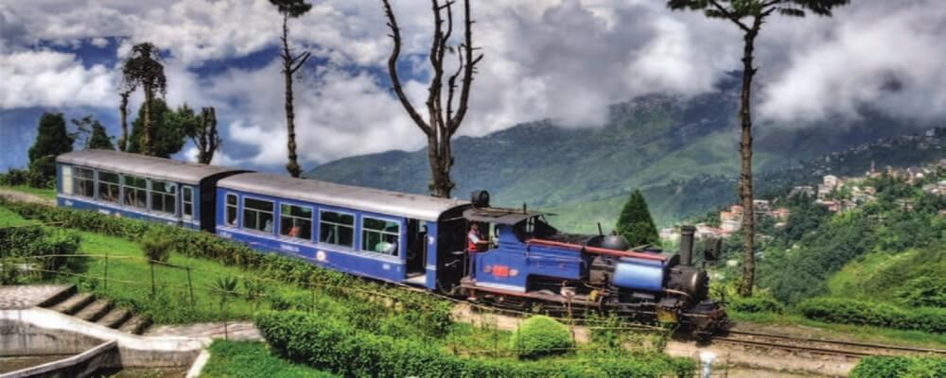

Happy Holidays!!!

