Why You Should Let Your Kids Cook With You

Source: Karina Chattlani, Integrative Nutrition Health Coach

I’m a firm believer in raising kids with essential life skills, which will benefit them throughout their lives. One of those skills is being able to prepare a simple nourishing meal (when age-appropriate), without depending on anyone else. I’ve personally found involving my son in the kitchen from a young age has been a wonderful way to develop these skills, helped us spend quality time together and created a myriad of memories.
There are numerous reasons to get kids involved in the kitchen and it’s not about them helping you out but instead about you helping them. From decision building to planning, building confidence and self-efficacy, from imagination and creativity to emotional bonding and nutritional knowledge having kids involved in the kitchen is vital for their cognitive, emotional and physical development.
Here are some age-appropriate tips to get kids involved in the kitchen.
6-18 months
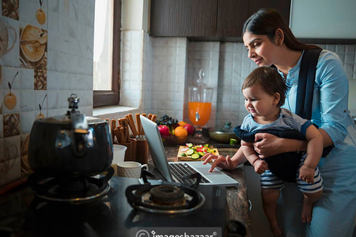
At this age, kids are normally by their Mom’s side, so bringing them into the kitchen is quite natural. During this stage, you could set them up in their high chair or let the crawl/walk around while you talk about what you are doing, and the different colours and shapes, let them smell and see the food being used, let them even touch some of the ingredients to activate all five senses. Another option is to give them a pot and spoon to imitate you. This stage is about getting them to start feeling comfortable in the kitchen.
18 months – 3 years old
This is the time they get SO excited to help in whatever way possible. Get them to do all the pouring and stirring. Allow them to tear greens into pieces – you’ll be surprised how much more willing they are to try new foods when they are helping you prepare them. Allowing your child to switch on the blender is a no brainer because at this age there’s no chance they’ll have it any other way. They still need A LOT of supervision at this age, but they will be so enthusiastic about being able to help you out in any way possible!
4-5 years old
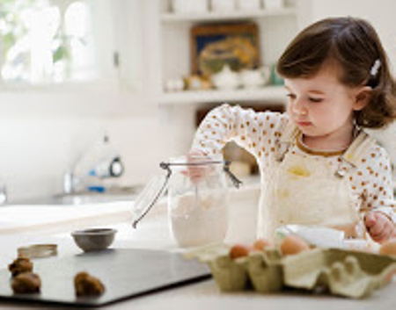
This is when the fun times really begin. They are now able to start taking the lead in the kitchen and take pride in the fact they completed it “all by themselves”. Get them to make a salad on their own - take them shopping for the ingredients then let them wash and chop it up (with a child-friendly knife) and mix up their own dressing to pour on top. Another idea could be allowing them to conjure up their very own smoothie concoction, which they can then make. They will be so proud of their accomplishment and excited to eat their own creation.
6-9 years old
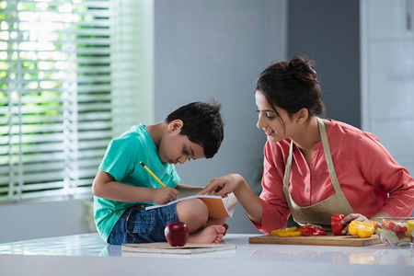
By this age kids have learnt to read so reading out recipes together and to set out on a few cooking projects is a great idea. You could try making yoghurt, or start planting some herbs, which could be used in some dishes you make together. Also getting them involved in menu planning is a great idea – give them two options to choose from per meal so you’re happy with either decision and they’ll feel like delighted that they got to choose.
When we let our kids get involved, it helps them to appreciate what’s on our table, have more confidence in their own abilities and they tend to be more open to trying new things. A trip to the supermarket means a lot more when they are invested in the final outcome.

