# **Why Your Child Needs To Explore Their Creativity**

**Source: Mareena Francis, Writer**

If in adulthood, creativity is a familiar force, it is a companion in most areas. It is vital then that a child meets creativity. It is in childhood that we can explore without a firm grip on reality and responsibility. It is here that we build our toughest traits. As parents, there is a decided responsibility to expose your child to creativity at a young age and easy ways to do it.

**Make them Learn, Not Study**

There is a stark difference between studying and learning, a distinction that serves us better the earlier we recognize it. With learning, it is an enthusiastic mind imbibing knowledge. It carries its memory for a long time to come, ensuring that we do not forget. As a parent, this is a significant but simple way to unlock your child’s creative side. There are always fun, and interesting ways to teach a child an otherwise mundane subject. Whether it be math, science or languages, use creative elements to teach your child and help them with their homework.

* **Use toys or objects around the house to explain math visually.**
* **Show your child fun videos that explain a concept differently.**
* **As some fun teachers do, create a rhyme or song to memorize something.**
* **Help them improve their vocabulary by watching movies and learning the meaning of new words you hear.**
* **Create quizzes and worksheets for your child and reward them based on performance.**

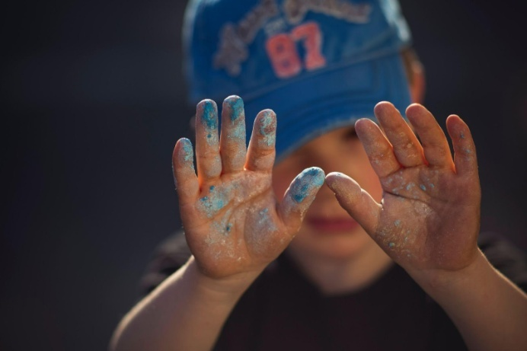When creativity makes its way into the learning experience, it gives a child a new way to explore a subject. By teaching them this way, you improve their learning and memory, heightening their interest in the subject.

**Take Them to the Art World**

Creativity is synonymous with art and artistry, an expression of emotions and the inner self. It is in the arts and extracurricular that a person learns about themselves and finds a breather from the mundane and stressful.As parents, involving your child in extracurricular activities is essential to their development. Other than the many mental and physical ways it helps, it also leads a child to their creativity. Understand what your child’s talent or interest may be, and give them a chance to choose an extracurricular activity they want to learn. This gives them a concrete skill, and also an outlet for their creativity.

These are some of the extracurricular activities you can involve your child in!

* **Painting**
* **Drawing**
* **Writing**
* **Dance**
* **Musical Instruments**
* **Singing**

They will learn to produce something out of nothing, with only their imagination and themselves to rely on. It is empowering and also an exercise of their creative muscle, honing a skill that they will carry on for the rest of their life. When a child recognizes a talent that explores their creativity, they find a commitment they can specialize in. This kind of commitment and specialization is what colleges go on to 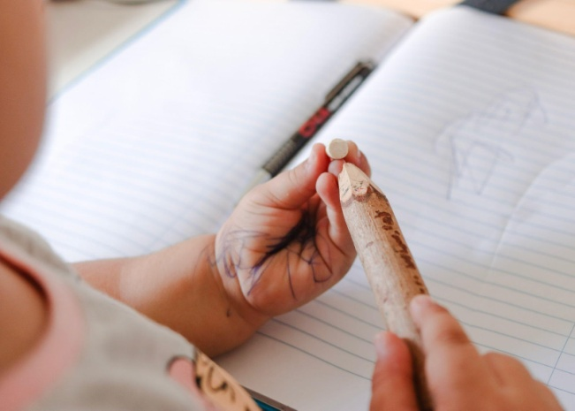look for, a solid milestone waiting down the road.

**Explore Your Own Creativity**

Often, we forget that much of what our children learn is from watching us. We set an example for them, giving them a precedent to aspire to. If our children see us only at work, they may not grasp the concept of creative pursuits. As a parent, your leisure time may not be significant. However, it is necessary that you also take the time to engage in a creative activity. When your child sees you being creative and having fun, they develop curiosity. This gives you an opportunity to involve them in what you are doing, creating productive quality time for both you and your child.

* **DIY Arts and Crafts**
* **Stitching Patterns**
* **Adult Colouring Books**
* **Zumba**
* **Read Out Loud**
* **Plant your Home Garden**

These are just some of the creative hobbies you could pick up and also involve your child in!

With such creative pursuits, a child has a hand in forming their own personality. It is this personality that grows and evolves into the future change makers and success stories of the world. They carry with them the creativity that never failed them, the passion that has now become so much more and the conviction to follow through on what they have started. With everything that creativity promises a child, and everything that a child stands to gain, it is necessary that parents expose their children to it. It is in such simple ways that you can lead your child to creativity, but its effects last for a lifetime.