What Is Hidden Hunger And How To Make Sure Your Kids Don’t Have It

Source: Nestle, StartHealthyStayHealthy
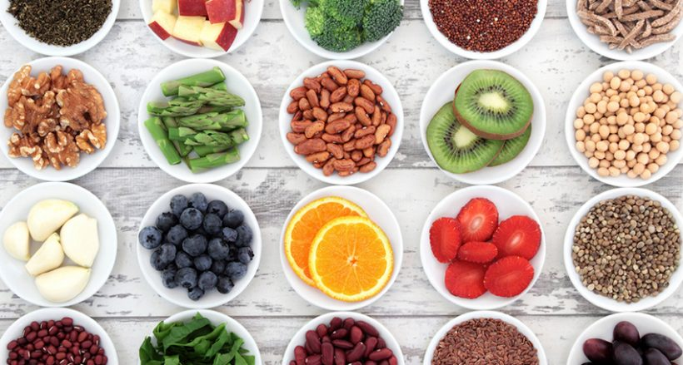
Your child could be eating healthy, according to you, but over a period of time if the quality of food you give your child lacks certain important nutrients your child could end up suffering from Hidden Hunger. Micronutrients are slightly trickier – they are your vitamins and minerals — and are really important for your child’s brain development and overall health.Lack of the following micronutrients in ones diet contributes towards Hidden Hunger. Foods like milk, cheese, eggs, yellow-to-orange vegetables like carrots, yams, and squash, and leafy greens like spinach are rich in Vitamin A and will not just work on your child’s eyesight but also make sure they don’t suffer from serious infections.

Every parent knows exactly what we are feeding our kids. We make sure their meals are balanced, healthy, and tasty. But kids can be fussy. My son went through a phase where he refused to eat anything that was green, red, brown or yellow. Think about it, that means no bread, curries, green vegetables or fruits! Just white rice, yoghurt, and lots of cheese. This is enough to drive any parent absolutely crazy! We are well aware of all the nutrients – proteins, vitamins, calcium – that we need to be feeding our kids but try as we might, there are a few gaps in nutrition. There is an epidemic that we don't know about. Have you heard of hidden hunger?

What is Hidden Hunger?
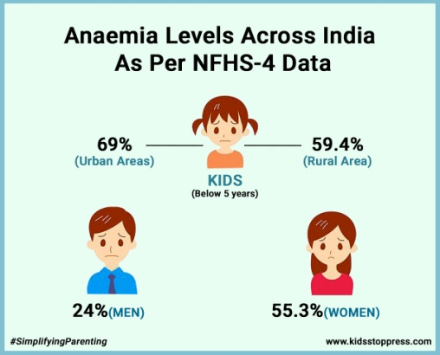
According to the World Health Organization, hidden hunger is the lack of vitamins and minerals in one's diet. Your child could be eating healthy, according to you, but over a period of time if the quality of food you give your child lacks certain important nutrients your child could end up suffering from Hidden Hunger.

Which Are The Nutrient Deficiencies That Lead To Hidden Hunger?
A balanced diet means an adequate amount of macro and micronutrients. Macronutrients – they are your carbohydrates, proteins and fats — provide calories and energy. Micronutrients are slightly trickier – they are your vitamins and minerals — and are really important for your child's brain development and overall health. Without essential micronutrients, children are prone to infections, impaired cognitive function, anaemia and low energy levels. Lack of the following micronutrients in one’s diet contributes towards Hidden Hunger.
Iron
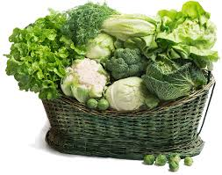
Iron is an important mineral that produces haemoglobin in your red blood cells that carry oxygen through the body. Iron deficiency means your body is unable to produce enough haemoglobin. And as a result, you might feel lethargic and lack the energy to carry out daily tasks. Iron helps red blood cells carry oxygen to the body and plays a key role in brain and muscle function. A lack of iron in the blood can lead to iron deficiency anaemia. If kids don't get enough iron it interferes with their brain development, slows down their growth and they become lethargic. As a result, a child with iron deficiency may have learning and behavioural problems. So making sure they don't get anaemic is extremely important. Green leafy vegetables are the easiest way to ensure your child gets their daily dose of iron.
Vitamin A
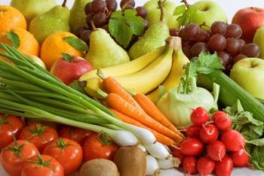
This is a fat-soluble vitamin and is very important for your child's eyesight. Foods like milk, cheese, eggs, yellow-to-orange vegetables like carrots, yams, and squash, and leafy greens like spinach are rich in Vitamin A and will not just work on your child's eyesight but also make sure they don't suffer from serious infections. Vitamin A is naturally found in breastmilk, so promoting breastfeeding is a natural way to ensure your baby gets their daily dose. Parents need to make sure their child gets Vitamin A once they are weaned.
Iodine
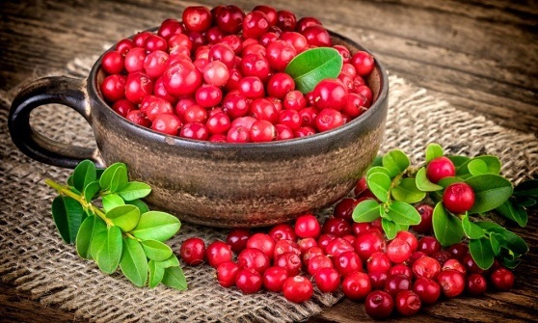
This essential nutrient promotes and supports thyroid function in children and adults. It is an essential nutrient for brain development and neurological functions. Iodine deficiency can lead to stunted growth, intellectual impairment and a lower level of intelligence. Iodine is needed only in small amounts but it is one nutrient that is often overlooked. Iodine is found in fish, cranberries, and strawberries and even if you cook potatoes with the skin on. In India, you can also easily buy iodine fortified salt.

Vitamin D
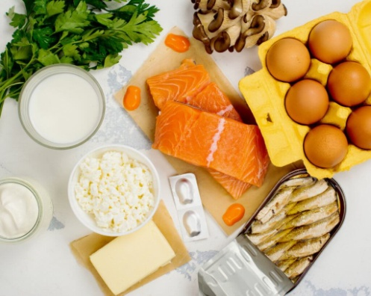
The sunlight vitamin is a fat-soluble vitamin that can be got in small doses from limited food. Besides supporting calcium metabolism in the body, Vitamin D also supports muscle and bone health, boost the immune system and overall development. While playing in the sunlight is one of the main sources of Vitamin D for children, they can get some part of it from the liver, mushrooms, egg yolks, fortified cereals and milk.
Zinc
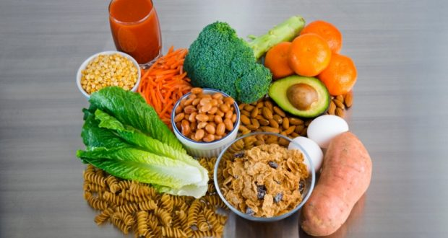
Zinc is an essential mineral that your baby/child needs for his/her immunity, wound healing healthy growth and development. Children who don't get enough zinc may exhibit appetite loss, poor immunity, weight loss, poor wound healing and mental problems. Foods that contain zinc are beef, chicken, crab, baked beans, yoghurt, oatmeal, cheese, peas, nut butter, milk and wheat germ. If your child is a picky eater then his/her doctor may suggest supplementation.
So making sure that your child eats a balanced diet that covers all the essential vitamins and minerals is key. We want our children to be healthy and energized for all that's ahead of them. Giving what they need in their developmental years is what's going to help sustain them later.

