Catalysing social and emotional learning through informal learning environments

Source: Tracy Cardoz,Director of Education, Square PandaIndia

“Children learn as they play. Most importantly, in play, children learn how to learn.” – O. Fred Donaldson, internationally recognised play specialist.
There has been much emphasis given to the importance of children attending early childhood education centres as it prepares them in early literacy, numeracy, and cognitive skills, or School Readiness as some call it. However, we often lose sight that ‘Life Readiness’ is the ultimate goal of education; the process of building important everyday practical and socio-emotional skills that your child will leverage throughout their life should begin in preschool years.
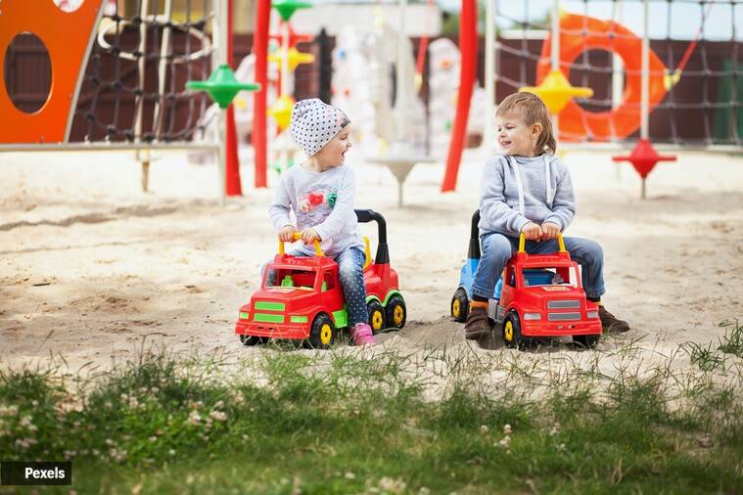
Social and Emotional Learning (SEL) is critical for helping preschool children

understand and manage their emotions, demonstrate empathy, form healthy relationships, establish positive goals, and make responsible decisions. SEL can be triggered by creating an environment that provides students opportunities to interact with other children and adults. Indeed, the best environments for SEL go well beyond classrooms, with natural settings like school playground, parks and even museums being apt catalysts.
Playgrounds and parks support free play, especially in groups where children learn important lessons in collaboration, conflict management, problem-solving, and more. Around the age of four, children begin to develop the “theory of mind”. This is a state of awareness that allows children to understand that other people have feelings, with viewpoints or objectives that may differ from theirs. This ability to see things from another perspective is essential for a child to make friends.
On the playground, the child learns the first important social lesson of making friends: the action of greeting with a simple “Hi!”, followed by a self-introduction. From here, children learn many accepted social scripts, like inviting others to play with them, expressing their opinions or disagreements, and even accepting others’ viewpoints. The ability to make and keep friends relies on a child’s ability to empathize and compromise.
Museums are great learning spaces, not only because they are treasure troves of historical artefacts, but also because museums are dynamic spaces that engage adults and children of different ages in conversations. The interactions one can have at museums extends to listening to others’ perspectives, and even to the realm of wonderment and imagination. Such interactions stretch children’s thinking, offering opportunities to explain what they know, and to hear about other people’s ideas. These are important SEL experiences.
Unlike the playground, where adults often take a backseat and are mere observers, museums are high engagement spaces. Indeed, an empirical study of SEL among 4-5 year olds in informal learning settings revealed significantly more instances of SEL among children in a museum environment vis-à-vis community playgrounds. This can be attributed to museums offering children a unique opportunity to hone and practice SEL beyond the traditional bounds of teacher-child interactions.
Thus, it can be said that SEL is a powerful lever for creating caring, well-rounded young individuals, and helps young learners to fully succeed in school and life.

