SIS # MARCH 17 # 02

Message from the Resident Director
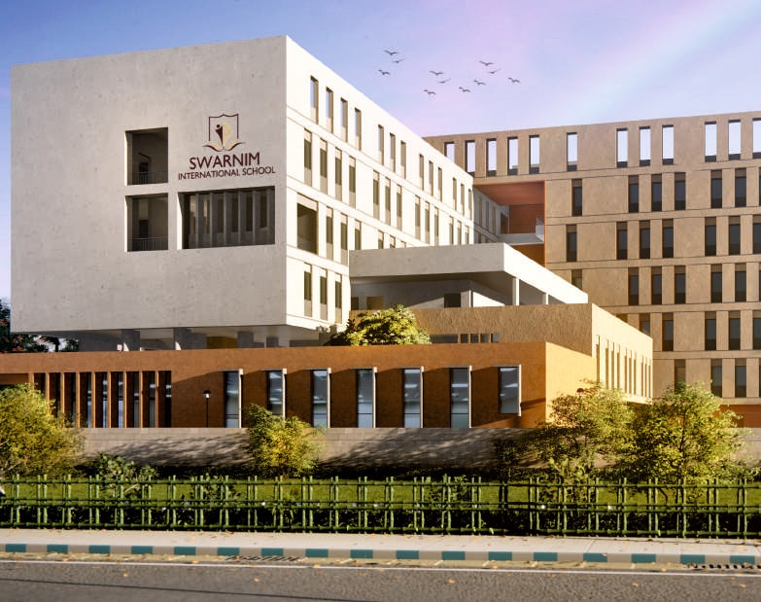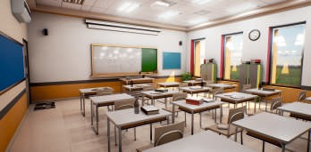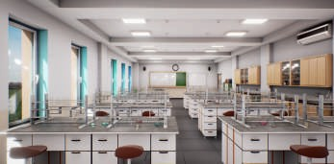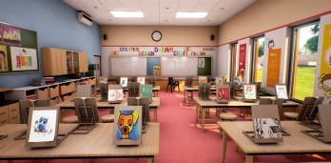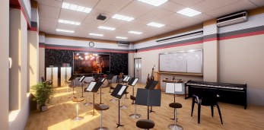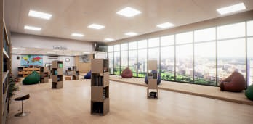Swati Sarawagi
Greetings from the Swarnim family!
2016 was a festival of firsts – Annual Day, Sports Meet, Republic Day celebrations and Graduation for our Fantastic Flyers as they move to Class I. We added a garden and a new floor to our facilities, many more children and teachers to our family. We are now a member of the Early Childhood Association and working towards receiving the
International School Award from the British Council. We are proud to nurture our students in an environment where they have roots of capability and wings of confidence. Each student has participated in the Annual Day and Sports Meet as well as a host of other activities on a daily basis. While 2016-17 saw many activities, 2017-18 promises to be even more exciting as we start Grades I-IV. We have handpicked dedicated and qualified teachers who will create a positive impact on our students. For the academic year 2017-18, classes I-IV will be held in the existing campus. In April 2018, students will move to the new will move to the new campus – a link to which is provided here- https://www.youtube.com/watch?v=nKyRjE7wzLA&t=53s
Work is already on in full swing to ready the premises. I thank all the Trustees, Parents, Staff, Well-wishers, Students, and their family members. Our journey would be incomplete without your being a part of the Swarnim family.
Let us embark on a journey where the child's love for learning will always grow.

New school campus to be ready in 2018

ANNUAL EVENTS

ANNUAL PICNIC :
On 22nd December, 2016, our children went for a picnic to a garden nearby. Students' day out was full of fun and laughter. Play teaches a child so much - from sharing to helping others to appreciating nature to observation to taking risks to even negotiation skills .They came back to school energized and enriched.

SPORTS MEET :
BLESS THIS MESS :
Educators and psychologists agree that we have been depriving children of the normal, non competitive forms of social play that are essential for developing a sense of equality, connectedness, and concern for others. So, on 27th February, our students were free to play with water, paint, mud and whatever they got their hands on. They even made small mud crates to sow wheat.

Our First Annual Sports Meet was held on 26th January, 2017. Smt. & Shri H. P. Budhia planted a Chhatim tree (Alstonia Scholaris), a tree synonymous to Tagore's abode of learning at Shantiniketan. The Chairman also released doves symbolizing peace and harmony in our community. This was further reinforced in Circle Time - a unique gesture spreading happiness and brotherhood as the students passed on one hug at a time. The novelty races, all based on themes of harmony, diversity and bravery, were designed with a learning objective in mind. This was followed by a Musical Corner for parents and a spectacular Yoga Display by the students.

ANNUAL DAY :
We celebrated our Annual Day on 18th March, 2017 at the Jai Hind Auditorium, Garia. Dr. Pallab Das, Chairman of Rajpur-Sonarpur Municipality was the Chief Guest. Shri H.P.Budhia delivered the welcome address followed by the Graduation Ceremony for UKG children moving on to the Primary Section. The Resident Director, Ms.Swati Sarawagi took the audience on a virtual tour of the upcoming school building. The brightest part of the day was the trilingual musical – Sunshine Smiles. Children aged 2 to 5 years portrayed a simple yet profound message– all hurdles in life can be overcome with a S-M-I-L-E. At the end, the audience, with smiles on their lips and sunshine in their hearts took a pledge to “Make the world a happier place.”

OUR ANNUAL DAY PROGRAMME WAS FEATURED IN THE FOLLOWING NEWSPAPERS:
Chapte Chapte, Prabhat Khabar, Dainik Vishwamitra, Aajkal, Millennium Post, Telegraph and Times of India.

CONNECTING CLASSROOMS
Swarnim is an active participant of British Council's Connecting Classroom, a global education program for schools, designed to help young people become globally aware and competitive in the 21st century. At the end of the in-depth course in creativity and imagination, our teachers learnt about the range and richness of creativity and how to nurture it to make it an integral part of learning and teaching.

We are also a member of the prestigious Early Childhood Association.

INNOVATIVE PEDAGOGY AT SWARNIM

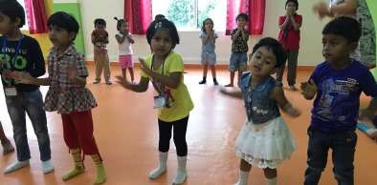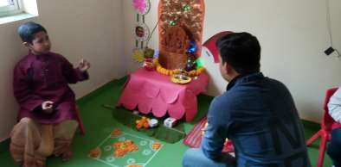RHYMES N RHYTHM :
Children's action songs are a fun and musical way to teach and reinforce language, choose new actions, sounds and ideas.
Every week, a new rhyme is introduced to the children in play form along with the old ones. Rhymes tend to be repetitive and have a strong rhythm. These rhymes are very effective for shy kids to open up and dance with the group.

FESTIVALS :
The lesson plan on festivals gave an opportunity to students to learn about the cultural traditions of four different states of India and appreciate diversity of cultures. Four corners of the classroom depicted the festivals namely, Durga Puja from Bengal, Lohri from Punjab, Pongal from Kerala and Christmas from Goa. Students gave a confident presentation to their parents about the festivals expressing their knowledge without any fear of grammatical errors.

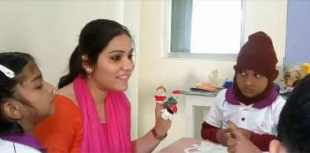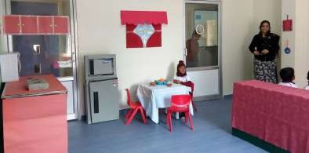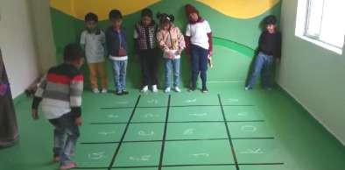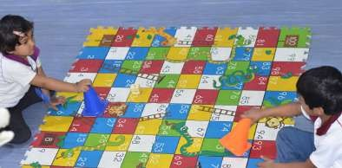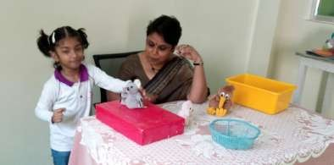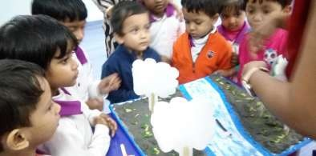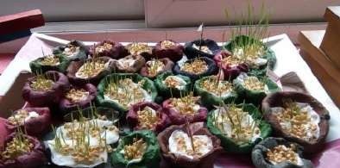DIPHTHONGS :
Each diphthong Ch, Sh, Wh, Th was introduced to the students with a story of Mr.H and his four cousins and illustrated with finger puppets. The expected learning outcomes from this lesson were to make children say and spell at least 5 words with each diphthong. The lesson was tailored to each child's needs. Each student was involved and was given a chance to say his own version of story with finger puppets.

ROOMS IN THE HOUSE :
The lesson “Rooms in the house” gave the learners the language needed to talk about where they live. The students learnt about six different rooms of the house, co- related objects to the rooms, and understood which rooms were meant for what. A few carton boxes, a few desks and chairs and old household items transformed a classroom into an apartment consisting of a bedroom, living and dining room and a kitchen. This room became the students' favourite place for a week till they knew everything about the place.

SPELLING :
Children were introduced to a game of Hop, Skip and Jump to break the monotony of learning to spell words from printed material. One group called out a word and a member of the other group had to jump to the relevant squares to form the word. Children loved the game as the challenge was not only the spelling but at times the distance between two letters.

ADDITION & SUBTRACTION :
Having mastered pictorial addition and subtraction, children of Upper KG had to move from concrete to the abstraction of using numbers only. A big mat was laid out with Snakes & ladders game. Through playing, they understood the important and challenging concept of addition. For subtraction they counted backwards to reach the starting point. Interestingly, students began to innovate new games. For example, they wrapped a cubical box marked its faces with numbers from 7 to 12 and made it their dice! Is this not what we must strive for?

PREPOSITIONS :
Prepositions were introduced with a role –play. Students were asked to place different things in different places. The teacher spread out a big picture on her desk, and asked them to place a pencil 'between' the girl and the tree in the picture. Then children asked the teacher to perform similar actions which engaged them completely.

STORY SESSIONS :
November 15th to 18th was Story Telling week where children enjoyed listening to stories, especially since teachers had illustrated them beautifully through models, flash cards, charts and role-play. Our students were engrossed while listening to the traditional fables like Lion and the Mouse, The Honest Woodcutter etc.

GERMINATION :
“All the flowers of tomorrow are in the seeds of today.”
On Bless the Mess day, our little ones made small clay dishes. Later, they painted these and planted wheat in it. For a week, each child watered his mini plantation and watched the shoots grow. It is a very simple way of instilling in them the concept of germination, living things grow and more importantly nurturing plants. These dishes were handed over to their parents on the last day of the session, almost symbolizing their child's growth throughout the year.

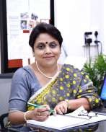
Message from the Headmistress
Rumjhumi Biswas
We are on the threshold of a new academic session. It is the time for new books, new school bag, new uniform and the excitement to enter a new classroom with a new teacher. The first day of a new session is nothing short of the New Year! However, for the preschoolers, the first day of school may be a source of anxiety as they do not have any idea of what to expect. So, there are tearful children and distraught parents in front of the schools. Tough as it may be, mothers should try not to stress if her child doesn't want her to leave his side — this completely normal stage of development will indeed pass. Eventually every child will outgrow the separation anxiety.
Preschool is great place for kids to interact with peers and learn valuable life lessons such as how to share, take turns, and follow rules. It is
the first place for the child away from home where he stays for a few hours, has food and relaxes. It is but natural that the child might take a few days to get accustomed to the new environment. During this acclimatization tenure the child might catch a cold, have slight fever and be edgy owing to the exposure to new conditions. Parents must understand this change of scenario and trust the teacher and have confidence that they have chosen the best preschool for their child.

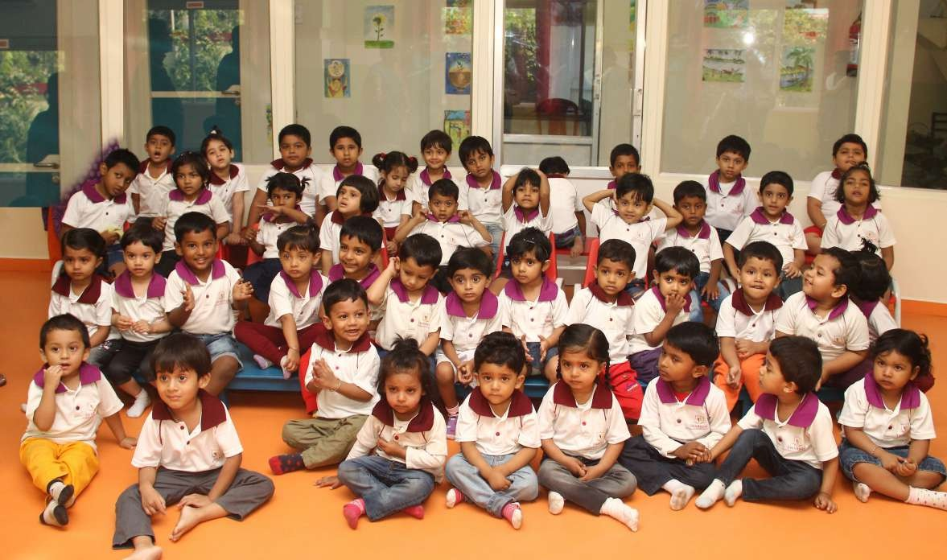
The first batch of Swarnim Stars

