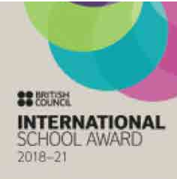
SIS # SEPTEMBER 2020

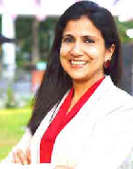

RESIDENT DIRECTOR’S MESSAGE

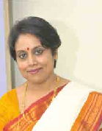Dear Parents

HEADMISTRESS’S MESSAGE

The phrase ‘new normal’ has become a part of our vocab- ulary after months of lockdown, social distancing, work from home and pandemic angst. In between all of these the government has also presented a New National Educa- tion Policy for us. We were thrilled to observe that several recommendations of the policy are already being practised at Swarnim:

- We inspire children to think and analyse situations critical- ly without enforcing our thoughts on them. Thus we teach them how to think, not what to think.

Experiential Learning has always been our way of im- parting knowledge. Education has never been confined to textbooks!

- We believe in multiple intelligences and every child’s re- port card reflects his or her emotional, ethical, co-scholas- tic as well as academic progress. This helps to understand the unique potential of every student.

We have bag-less days to relieve children from their stress and engage in enrichment activities.

- Our curriculum focusses on ideas, application and problem solving methods so that children can acquire practical and useful knowledge in every subject.

Parents are the first teachers of their children. In this new normal era, they have even come inside the classrooms as their homes have now been transformed into classrooms. They have been witnessing and observing how their children are learning. We are humbled to have won their appreciation regarding our teaching strategies throughout. They have become our quintessential partners in continu- ing the successful educational journey of our children. We are forever grateful to all parents of the Swarnim family!

From the beginning, our teachers have been receiving continuous professional development through several workshops and webinars. At present, we have also started a parent webinar series where different and difficult aspects of parenting will be addressed by experts. Raising another human being (Parenting) is the most important responsibil- ity anybody holds and there is absolutely no training for it.

We hope that these webinars will help to answer different queries and guide you in your parental endeavours.

When we embarked on the journey of online class- es we were looking at a period of roughly six months till the schools reopen. Deliberations continue about online schooling as fallout of the pandemic. Whether this is just a situational change or a perpetual transition from the old normal of teachers and students sharing the same physical space, only time can tell. There has also been a pandemic of webinars to discuss various aspects of online classes.The optimists discovered positives and the cynics enumerated the ills. But everyone wants to move about undaunted, un- encumbered, and untrammeled again soon.

In spite of the wide gamut of topics discussed on various digital platforms, and very earnest tributes to the “covid warriors” spanning a plethora of professions, two extreme- ly crucial contributors are rarely mentioned. They are the teachers and the homemakers.

Teachers have always been considered as a very rigid group: technophobic, traditional tortoises who win being slow and steady. But they created AWE – Awareness, Well-being and Excellence as they transformed themselves and the concept of schooling. Our teachers embraced the hardships, sacri- ficed their holidays, befriended technology, doubled their duty hours, ignored their own illness, curtailed their family time, so that learning of our children continues unhindered.

And the unassuming homemakers, accepted the changing home scenario, unflinchingly shouldering the burden of the entire family’s demands round the clock, sacrificing their me-time so that the quality of life of children and spouses is not compromised.

We mustn’t forget those teachers who are parents too. We can well imagine the uphill battle of juggling the two roles and only thank them profusely. Swarnim strives to inculcate empathy, sensitivity and gratitude in the students for all, so that they can build a better world for themselves.

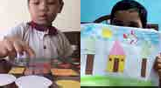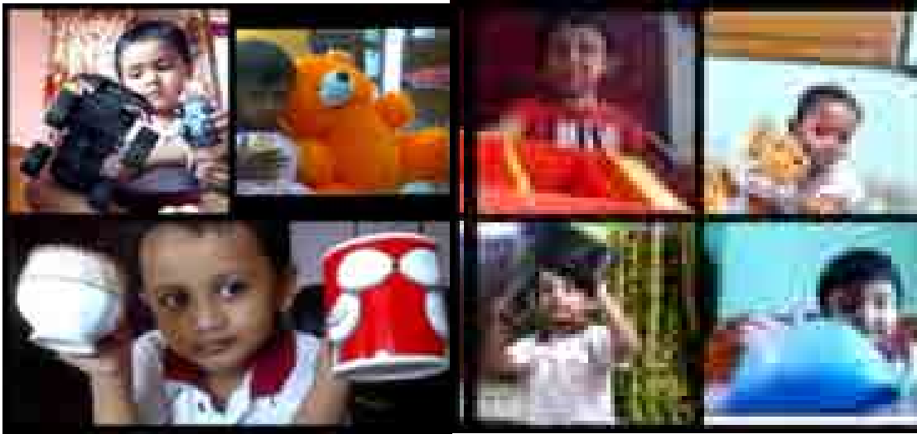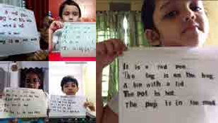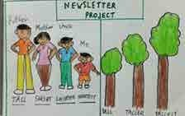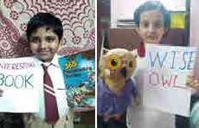

Nursery – Big & Small
Our nursery children were introduced to the concept of big and small with the help of different objects. The children were asked to gather a few objects which were similar but of different sizes and was asked to hold it and point to big/small objects. This was followed by an activity where they had to tear two different coloured papers and paste the bits on big and small circles.

LKG - Sorting & Pasting Shapes
The children did an activity with cut outs of different shapes . With those shapes only they had to create a picture with minimal help from teachers and parents. Children came up with excellent presentations. This activity not only reinforced recognition of various shapes but also stimulated their creative and critical thinking skills.

UKG - Newspaper letters
UKG students collected letters from newspaper headlines and maga- zines and made meaningful sentences with them. They then pasted the words on a paper and made it into a short paragraph. The activity stimulated their comprehension and enriched their vocabulary.
They learnt to frame sentences. Cutting out the letters and pasting it strengthened their fine motor skills too. The icing on the cake was their lovely smile after completing the activity successfully.

Class 1 – Comparison
Children were introduced to the topic “Measurement” in a unique way. They were asked to depict some things of their choice in the order big- gest to smallest. Children used fascinating ideas to represent the same and enjoyed learning the concept of measurement. They described their illustrations using the concept of degrees of comparison in Adjectives. At Swarnim, subjects are mapped to each other to give children a holistic experience. In this activity English and Mathematics concepts were mapped.

Class 2 - Adjectives
Students learnt to describe a noun with proper adjectives. “Show and Tell” was an activity through which the children discovered “Adjectives”. Each child displayed their favourite object and described them using a suitable adjective. Finally they wrote those words on
a piece of paper. This activity enabled them to learn the describing words and also to observe their favourite items more keenly.

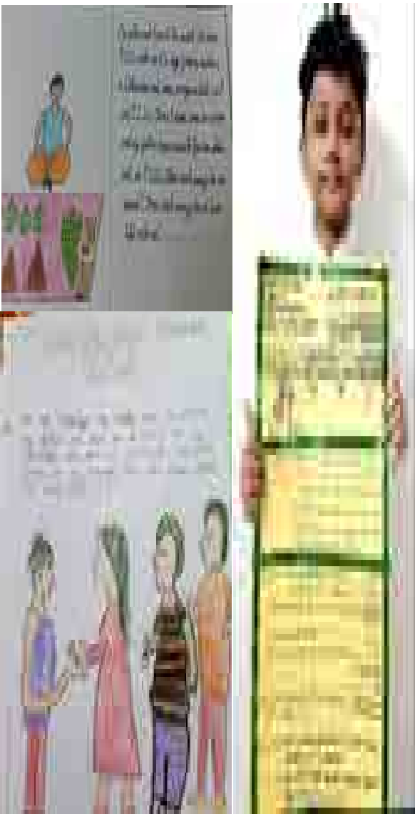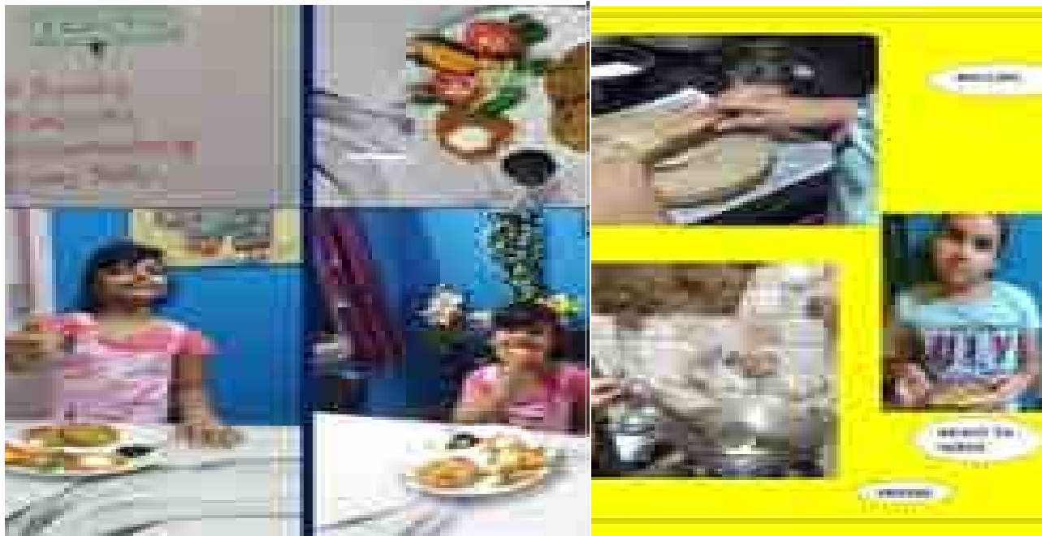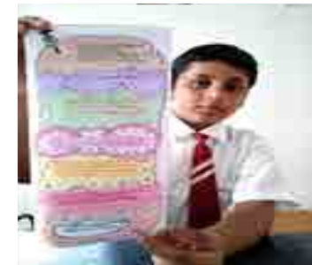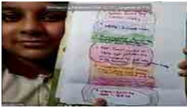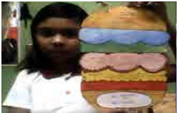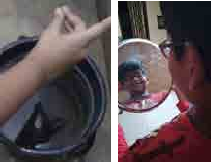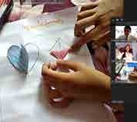

Class 3 – Story Sums

Learning how to work and write a word problem is an important part of a student’s learning process. Word problems teach problem solving, life skills and creativity. It really shows kids how Mathematics works in the real world. Students wrote their own story sums from their personal experiences related to the four basic operations of Mathematics. Clarity of concepts can’t be better than experiencing it!

Class 4 – Menu Mania

The students were asked to close their eyes and visualize a mouth watering dish of their choice. After several suggestions, the final dish decided was “Raj Kachori”. All of them made the dish and then the recipe was discussed and broken down into different parts of speech. This activity not only taught the students to create procedural texts such as recipes, but also made them learn writing in steps. They had to brain-storm and learn parts of speech by categorizing the ingredients as nouns, the acts of preparing as verbs and the taste as adjectives. The recipe is a form of instructional writing.

Class 5 – Cheeseburger
We did a fun project that made the children hungry to read their literature text- book! We made a Story Cheeseburger. Children drew the different layers of a mouth-watering burger on a chart paper. Every layer was designed to represent a key element of the story. While the bread on top said the title of the story, its author and genre, the following layer of onions explained the setting of the story and so on. Children broke down the story into parts and analyzed its plot and conclusion before summarizing them briefly on their burgers.

Class 6 - Reflections
Science is all around us. We just need to keep our eyes and ears open to understand the secrets of science. The students studied about reflections. They were asked to survey their surroundings and report their observations. They could either present
it by clicking pictures of it or by drawing it. The students were amazed to find out where all they could find reflections. They found in the water bodies, they found it on the utensils and they found it on their spectacles. Hence, this proved the fact again that behind every move in nature one can find a whole lot of science.

Class 7 – Symmetry
Symmetry is a fundamental part of geometry, nature, and shapes. Symmetry exists in patterns and is found all around us. It is a balanced and proportionate similarity found in two halves of an object, that is, one-half is the mirror image of the other half. It is im- portant for students to grasp the concepts of symmetry as a means of exposing them to things they see every day that aren’t obviously related to Mathematics but have a strong relation to it. Students performed simple activities which demonstrated reflection and rotational symmetry. They used paper cut outs of the geometric shapes to explain line of symmetry and find order of symmetry of the shapes drawn.

Parent webinars :
Parent webinars because parents have the most important responsibility in the world- raising young human beings. Parent webinars were held on topics like - health is wealth; stop spanking - reasons and effects; raising emotionally intelligent children; empowering children to protect themselves sexually
Click to View

ENRICHMENT & EXPOSURE

When teachers stop learning, so do students. Effective teacher learning and professional development is important for student achievement. Our teachers attended the following webinars conducted by eminent personalities in the field of education.
Pre-primary teachers attended a 5-day online workshop organized by Square Panda. Facilitators included accomplished educationists like Ms. Sonia Relia- Consultant for Activity Based learning; Mrs. Kajal Chhatija – Principal, Rims International School, Pune; Dr. Seema Negi –Principal of Sanjeevani World School; Ms. Bela Kotwani- CEO, Cosmikids and others

Webinars on understanding special needs of children was conducted by Ms. Rakhee Chhabra, Caring Minds; HLS India and CEM..

Dr. Swati Popat Vats, President of ECA & APER conducted a webinar for her book launch of Ms. Pencil and her team. She also conducted various other webinars like -IQ & EQ in Early & Primary Years, Coding in Early Years and Teaching & Learning in ECCE.

FICCI Arise organized webinars for Primary and Secondary teachers on Creating lesson plans, Teaching for the new normal, Designing Online Assessments, Building parental involvement and Mental Wellbeing.

The National Education Policy 2020 was discussed at length by experienced educators like :

Ms. Swati Sarawagi - Resident Director of Swarnim International School and Territory Head of ECA.
Mr. John Bagul – Founder Principal of South City International School.
Mr. Ankur Vohra- Director Outreach and International Admissions O.P Jindal Global University.
Ms. Suman Sood – Director BD Memorial.
Ms. Swapna Simmi Sukul - Ambassador -School Programmes British Council India and Global ASL Trainer.
Mr. Amitabh Mohan- Educationist and Psychologist.

Webinar on the International School Awards was organized by British Council.

Prof. Rajaram Sharma, Professor and Head, ICT- NCERT conducted a webinar on Schools after lockdown-Redefining existence.

CENTA – Centre for Teacher Accreditation conducted webinars on Removing Math Phobia and Building a Mathematical Mind, Model method for solving word problems, Augmented Reality in classroom, Online Teaching Competencies, Design Thinking.

Math Pedagogy webinar series was conducted by Kelly Lim, Head, Learning and Development, Singapore.
Transition from classroom to online teaching organized by EduExcellence.
Continuous Professional Development organized by Oxford University Press.

Ms. Chhayya Aggrawalla of “Life on a Canvas” is a very talented and passionate artist and speaker. We had the privilege of
having a Mandala Art workshop for classes 5 to 7 with her. Mandala Art is a perfect blend of art and geometry as one can create beautiful intricate designs through a series of symmetrical circles and patterns.
Click to View

WORKSHOPS

Studies continued as per the academic calendar. Students became more even more responsible for their own learning.
Different workshops were conducted by experts for the students. Yoga by Ms Shraddha Setalvad ; Non fire cooking by Ms
Manjari Agarwal, fitness by Ms Swati Agarwal ; book reading by Ms Smita Jee; Coding by RoboGarden ; self defense by Safe Campus ; gardening by LoveGreen ; story telling by Golpodidi.

Novelty makes learning interesting.
Click to View
And their love for learning continued to grow.
Students learn life skills as an integral part of their education.
Click to View

Click to View

Reading is always given a lot of emphasis in Swarnim

Click to View

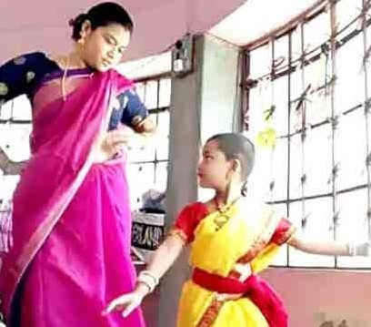

Rabindra Jayanti

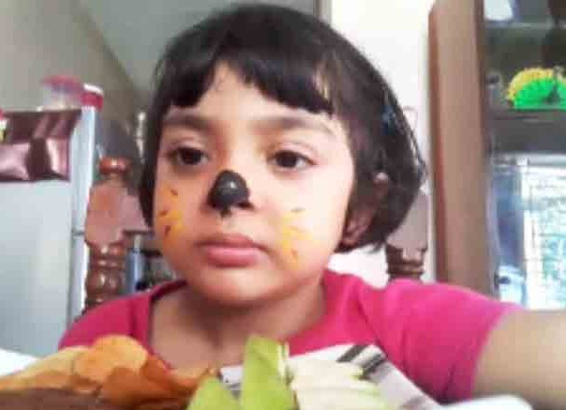
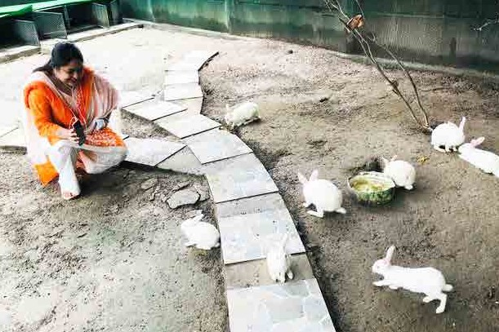
Online Class Party

Reading Week
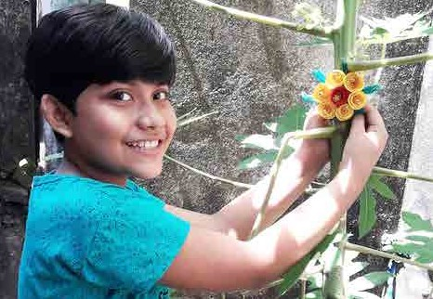

Raksha Bandhan With Nature

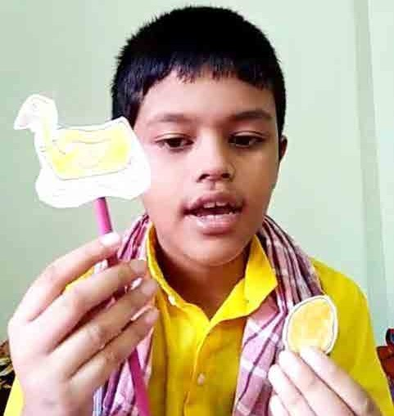

Virtual Tour of SIS Cloud Watching

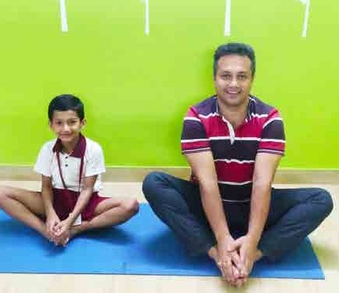

International Yoga Day

International Dance Day

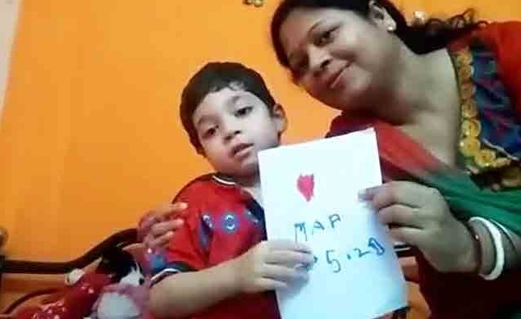
Mother’s Day

Hindi Diwas
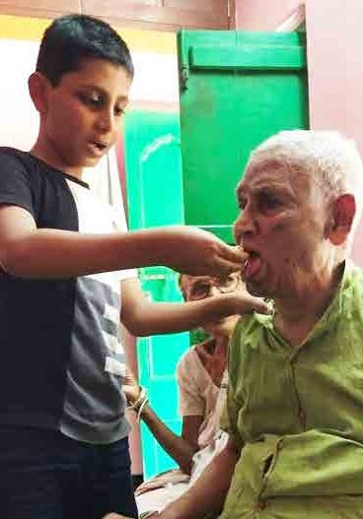

Caring for Our Elders

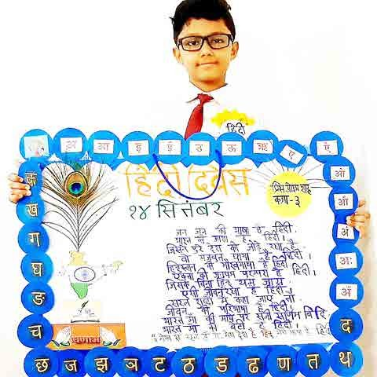

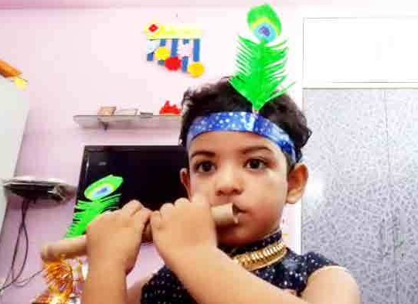

Janmasthami Yoga
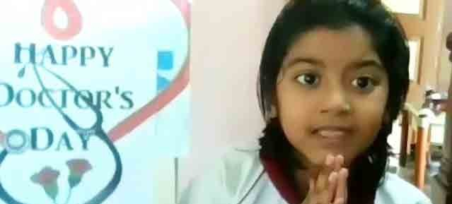

Reading Week
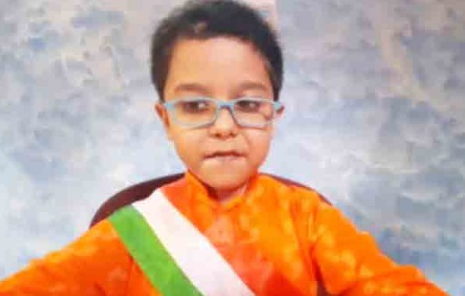
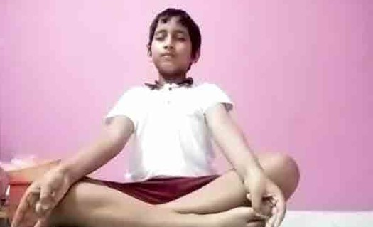

Independence Day Meditation

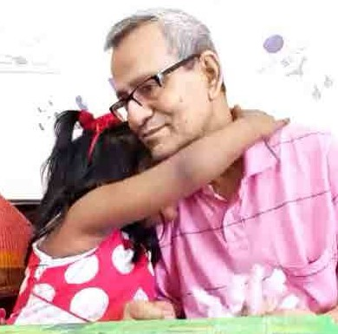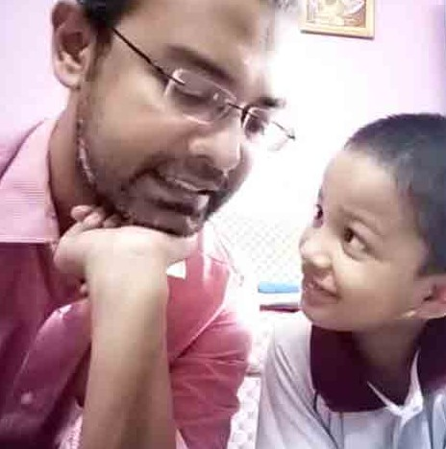

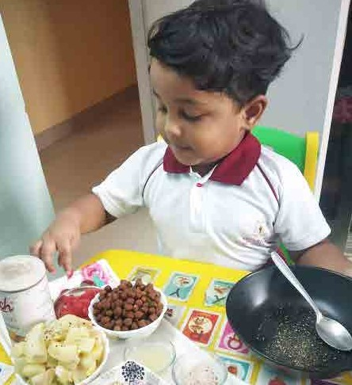
Non-fire Cooking
Grandparents’ Day

Father’s Day

Click to View
Follow our YouTube channel for more photos & videos like these

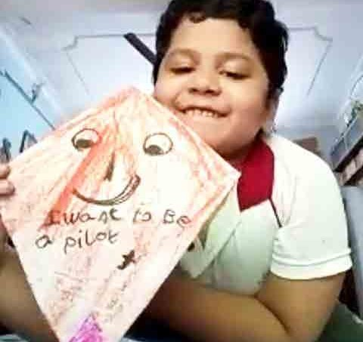

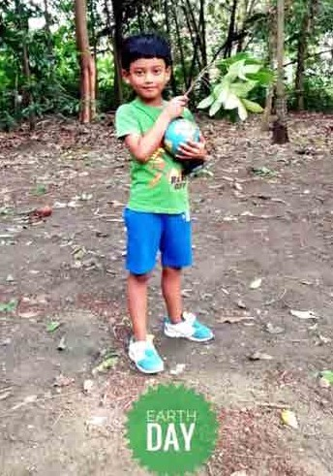
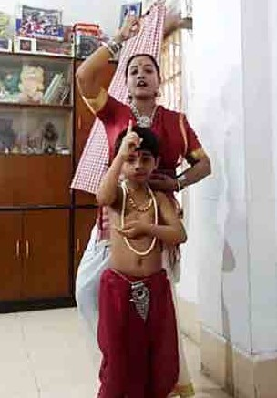
Kite Making Earth Day Teacher’s Day

