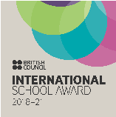
SIS # OCTOBER 19 # 07

RESIDENT DIRECTOR’S MESSAGE

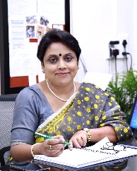At Swarnim International School, we work towards providing a challenging, enriching and stimulating learning environment. We have a strong emphasis on academics, but as part of a greater picture. That's why we have term books, which keep a school bag light, we have daily reading and we have exams only from Class IV onwards.

HEADMISTRESS’S MESSAGE

We encourage children to maximise their potential and explore new possibilities available to them. That is why as part of the holiday homework we had Having Fun and Being Outdoors.

Independent skills and curiosity are developed in order to enable children to naturally inquire into new concepts. That is why we request parents not to send students for tuitions, rather to let them discover the world as they are ready for it.

Whether on the stage, sports field or while serving others, we want the children to discover who they are and what they are truly capable of achieving. That is why we have a range of activities from Reading Week to Learning Life Skills to Collecting clothes for flood victims. And of course, our much awaited Annual Day and Sports Day, always replete with a social message.

We want children to be aware of themselves of their true intrinsic nature and to be confident about themselves. That's why we have yoga and meditation, and self defense classes and a range class room of activities based on Multiple Intelligences so that each child can discover their best learning styles and what interests them the most.

We believe we need to work together to create an environment for true development that will benefit our children. That's why we have a Tree of Appreciation, Star of the week, and Fruit Week.

We are proud of our students' accomplishments and look forward to parents' partnership to construct on their existing knowledge. That's why we have Workshops for parents, Grandparents Day Celebrations, Good Touch Bad Touch sessions, and Traffic Awareness.

We also believe in continuously bettering ourselves through better infra structure and professional development workshop for teachers. That's why our teachers are always learning new and better ways to improve.

With this in mind we present to you the activities that have taken place in school in the last 6 months.
I would like to share an incident which might give us insights about a pertinent issue which is worrying all educators and parents alike -the issue of value education or alternatively, character education.

A 6 year old girl complained of dizziness, numbness and “heart palpitations” to her class teacher repeatedly for a few days. The teachers were extremely concerned and the matter was reported to me. After an interaction with her, I could gather two facts; first, this was her ploy to seek attention and second, she was imitating someone's mannerisms. We informed her parents, who revealed that her mother was suffering with such symptoms.

We were aware that the child was not “lying”, she was“role playing” to elicit importance from others. This continued for a few days and then it stopped suddenly. Her mother came to meet us and said that one day her daughter went up to her after returning from school and confessed that she was lying about her illness in class. She would never do such things again, because she realized that no one would believe her anymore, like the story “the shepherd who cried wolf”. Incidentally, this fable was narrated to them in their class. Children were asked to ponder over what they learnt from it. Needless to say, this little girl had a lifelong learning. That is the impact a well narrated story can have on children.

We must realize that values or ethics cannot be instilled through lectures or imposition. If we want our children to internalize certain moral values for a sustainable future, we need to find better ways than we did all these years. The premise of our ancient traditional education system was value based learning where knowledge was incidental. It is ironical that in this knowledge age we strive hard to fill their minds with information which is at their fingertips at the cost of moral education. In our school, we appreciate children who evince good qualities on the Tree of Appreciation to reinforce those.

In school we attempt to craft pedagogies and supportive structures to foster the development of positive, ethical, pro-social inclinations along with academic achievements. We try to have an eclectic mix of methods which comprise of parenting strategies, peer interactive strategies, cooperative learning, role-modelling, developmental discipline and character education through various activities.

At Swarnim, we believe in invoking one's good self through self realization. For very small children, this comes through when they can relate to characters and settings. And they can do that only when stories come alive for them. Thus, whether it is the Annual Day or the Sports Day, Swarnim has a social message to convey. When children practice for these events, I quote what danseuse and reformer, Alokananda Roy, commented after watching our show “I Can, I Will”, “Somehow these values percolate deep within them and remain with them life long.”

Swarnim reiterates its commitment of growing good human beings with the synergy between parents and the school. We wish this festive season light up our darkest corners.

CURIOUS CLASSROOMS GLIMPSES
“I never teach my pupils; I only attempt to provide the conditions in which they can learn.” - Albert Einstein

Nursery  The children of Nursery identified letters E, F, L and H on their own. They were given a maze of letters and were asked to circle the specified letter. For the toddlers it was nothing less than a treasure hunt! |  | 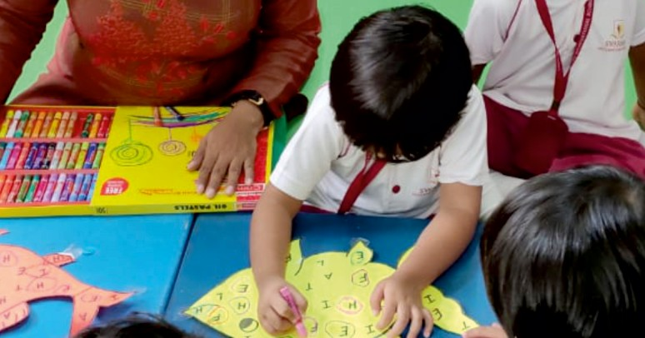
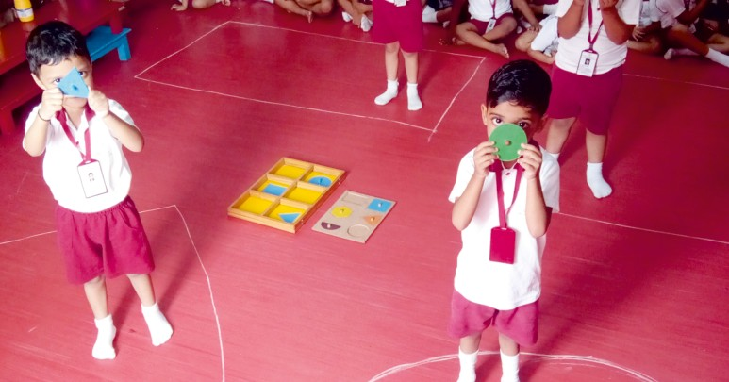 | LKG  Lesson planning at Swarnim is always a very interesting job because it is a blend of studies and fun. Recently various shapes were introduced to LKG children using different wooden blocks. Shapes were drawn on the classroom floor. The students were asked to pick up one wooden shape block at a time and stand on the same shape drawn on the floor and name it. This method appealed to all children with varied learning styles.
UKG  The students of UKG revised the topic describing words in the lap of nature. They were asked to observe nature and collect a few things from the garden. They were given a worksheet where they were asked to describe the things they collected and paste it on the worksheet. The children could touch, feel, see and smell the different things of nature that they collected. This was a sensorial activity to reinforce the concept of adjectives. |  | 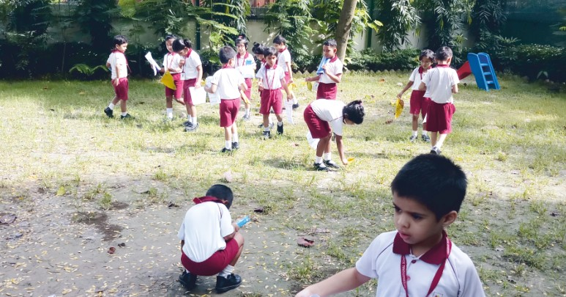
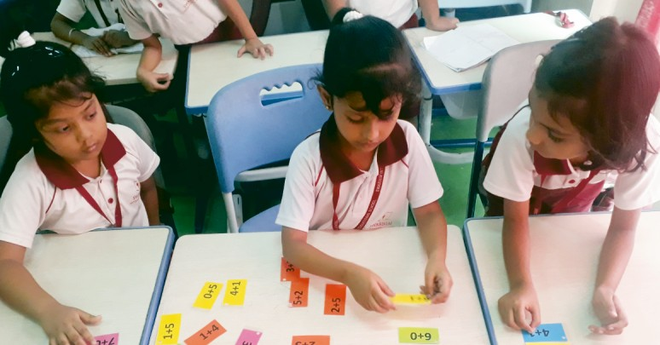 | CLASS 1 - Number Facts  Children did a group activity with addition strips to clearly understand the addition properties. Even the ones who shy away from numbers had a field day juggling with them.
CLASS 2 - Human Abacus  Children learnt the concepts of place and face value of a digit with the human abacus. Three students formed the abacus while the others put paper strips around them to represent the number displayed. It was a refreshing break from checkered notebooks to drill a very important fundamental concept of arithmetic. |  | 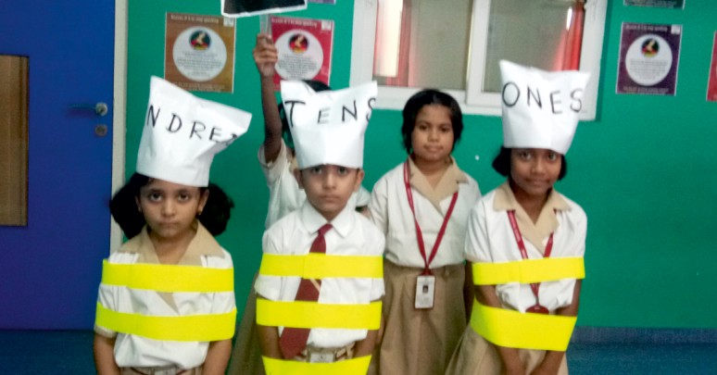

CURIOUS CLASSROOMS GLIMPSES
“I never teach my pupils; I only attempt to provide the conditions in which they can learn.” - Albert Einstein

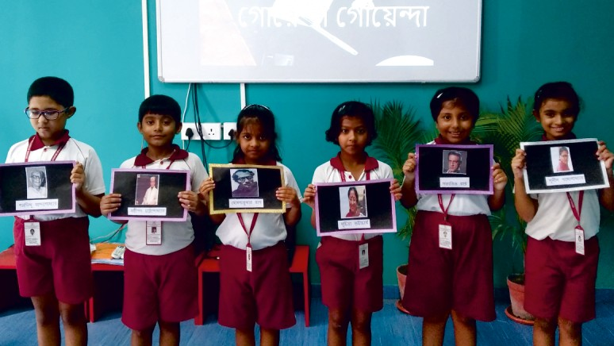
CLASS 3 - Detect Detectives
Who does not love mysteries and adventures? To arouse the curiosity in the students to read Bengali books, an activity about the fictional detective characters in Bengali Literature and their creators was conducted. The students played a match & pair game on famous fictional detectives like Feluda, Byomkesh, Kakababu, Mitin masi, Pandab Goyenda etc. and their creators Satyajit Ray, Saradindu Bandopadhyay, Sunil Gangopadhyay, Suchitra Bhattacharya, Sasthipada Chottopadhyay etc.

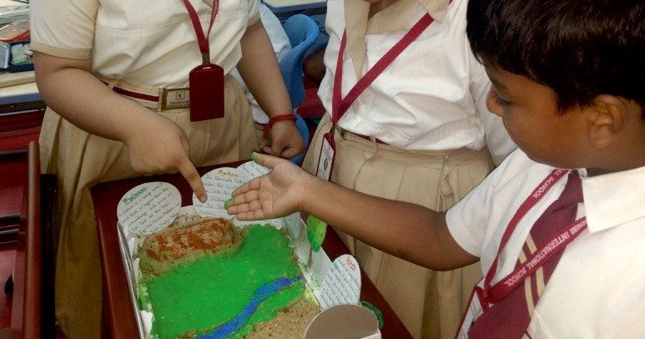

CLASS 4 - Landforms
Students applied their knowledge about different types of landforms in making clay models and using visual aids like pictures, drawings, cut-outs etc for a class presentation. This activity reinforced some of the observable differences among the features of the landforms. It also helped the children to visually understand the varied landforms.

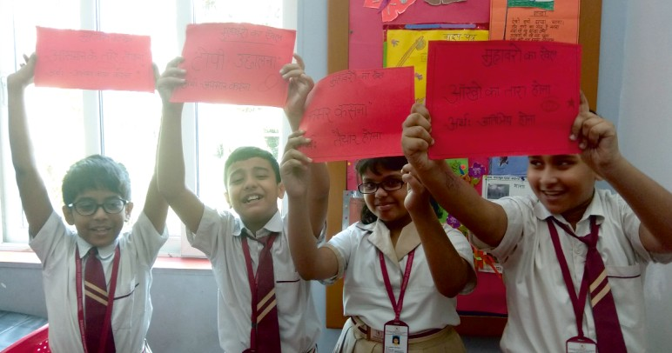

CLASS 5 - Dumb Charade
The students played DUMB CHARADE with Hindi Idioms. One student acted out the idiom and another one tried to guess it. They made sentences using those idioms. Learning Hindi can be fun too!

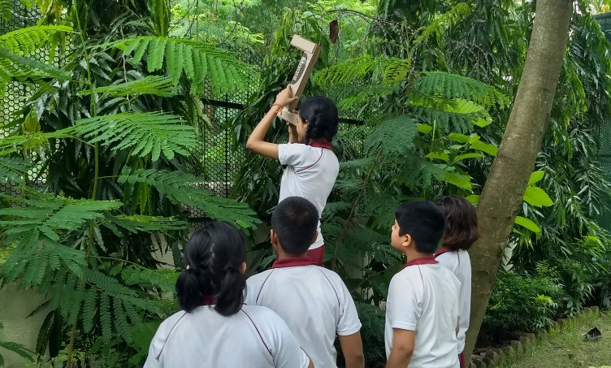

CLASS 6 - Troubleshooting
The students of Class VI were facing a peculiar problem. When they went for their P.E class, they often lost the ball as it was accidentally thrown, hit or kicked over the boundary wall while playing. They needed something to locate the ball. So, they made a periscope for themselves. As science students, they learnt recycling too by using cardboard from old cartons. They measured and cut the cardboard. They put mirrors at 45 degrees and parallel to each other. And when the periscope was finally made, they could locate the ball and get it back.

EXPOSURE AND ENRICHMENT
“Education is the most powerful weapon which you can use to change the World.”-Nelson Mandela

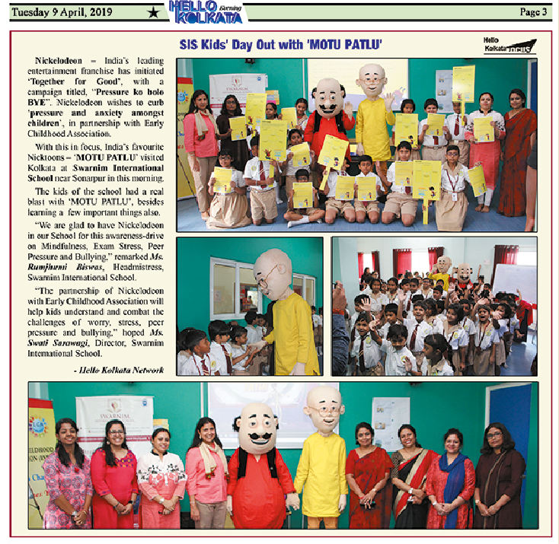
India's leading entertainment franchise, Nickelodeon,
returns with the Indian chapter of its International
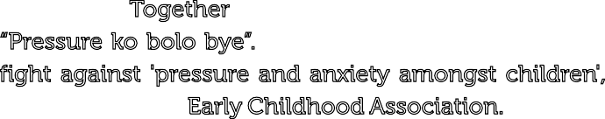property - Together for Good, with a campaign titled,
“Pressure ko bolo bye”. This year, Nickelodeon puts up a fight against 'pressure and anxiety amongst children', in partnership with Early Childhood Association. To start this initiative, India's favourite Nicktoons Motu Patlu visited Kolkata at Swarnim International School on 9th April, 2019.

The kids of the school had a real blast with “Motu Patlu” besides learning a few important things.

The brand started the extensive awareness-drive at the school with a two-fold module to discuss four topics -
The module for kids was exclusively designed with fun and interactive group activities with Nicktoons that stir changes and motivate children. Quirky Certificates were given to students, teachers and parents who attended the sessions.
Mindfulness, Exam Stress, Peer Pressure and Bullying.

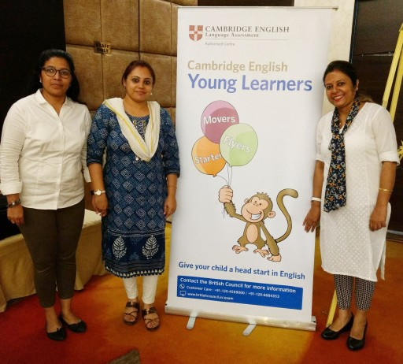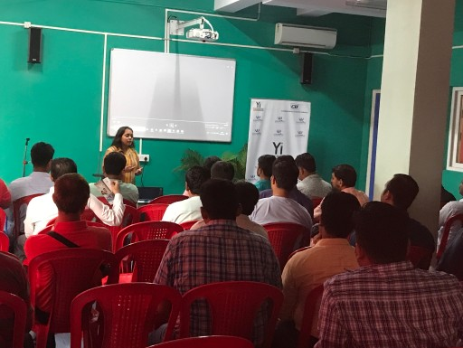WORKSHOPS:
Besides the mandatory annual Professional Development Week at the beginning of the academic session, Swarnim teachers continuously learn and upgrade themselves.

22nd June – All teachers attended a workshop in the school on Positive Behaviour Counselling by psychologists and counselors from Caring Minds .

24th June- Our teachers, Ms.Ratna Dev, Ms.Nisha Nair and Ms.Sumana Maulik participated in English Language Teaching – Teacher Support Program by British Council at Auris Hotel. Renowned English trainer Mr. Prakash was the facilitator.

29th June – On Father's Day, besides the celebration fathers also attended a workshop on “Good Touch, Bad Touch” conducted by Young Indians

13th July – Pre primary and primary teachers attended the Early Childhood Association Conference – Crossing the Line at BCC&I. Many eminent personalities, heads of school and educators shared their experiences and knowledge. The topics of discussion spanned from value education in early years to innovative teaching methods.

31st August - A workshop on 'Smart Parenting' was conducted by Ms.Mohini Ojha, special educator from Caring Minds .It addressed the challenges that parents face in bringing up children in this digital era.

22nd Sept – Ms.Somrita Adhikary and Ms. Anushree Keshan attended a workshop on English Teaching Strategies organized by the Oxford University Press at The Park.

26th Sept –Swarnim was glad to have Ms. Suchismitra Sen Basu of One Earth conduct an interactive session with primary students and teachers regarding Environment Awareness. Ms. Sen Basu was pleasantly surprised to find our children quite aware of the dangers to environment and also vocal about the measures to tackle those.
Children were given a 30 day task- calendar as vacation homework.

HIGHLIGHTS OF EVENTS
“You can teach a student a lesson for a day; but if you can teach him to learn by creating curiosity, he will continue the learning process as long as he lives.”- Clay P.Bedford

YOGA DAY
YOGA DAY
WORLD DANCE DAY

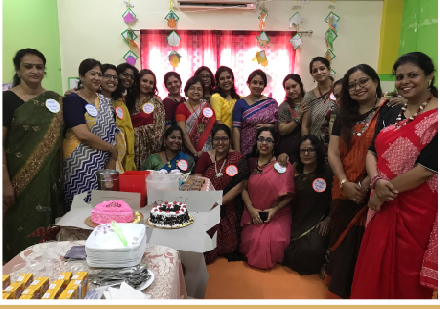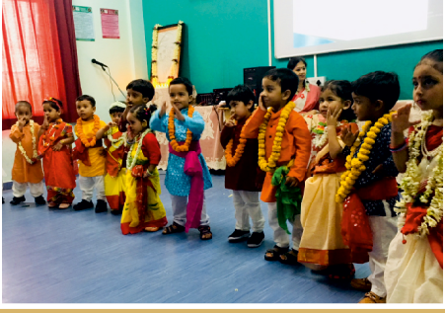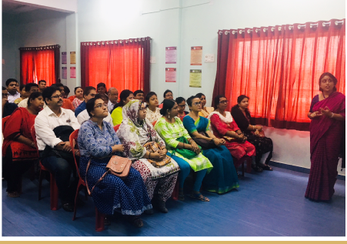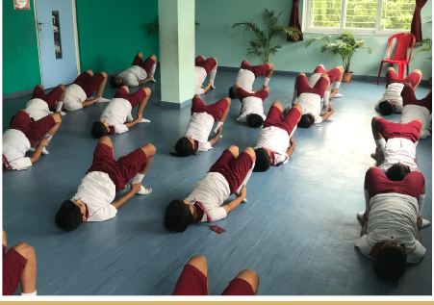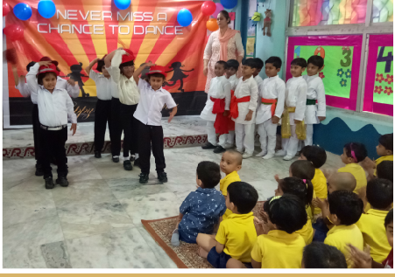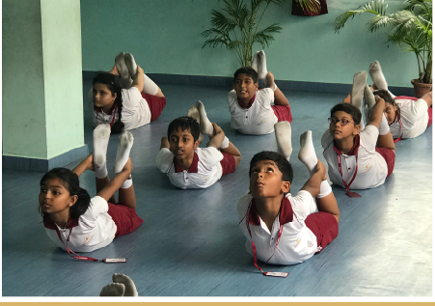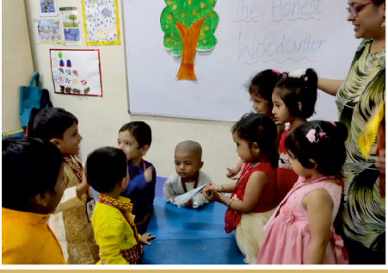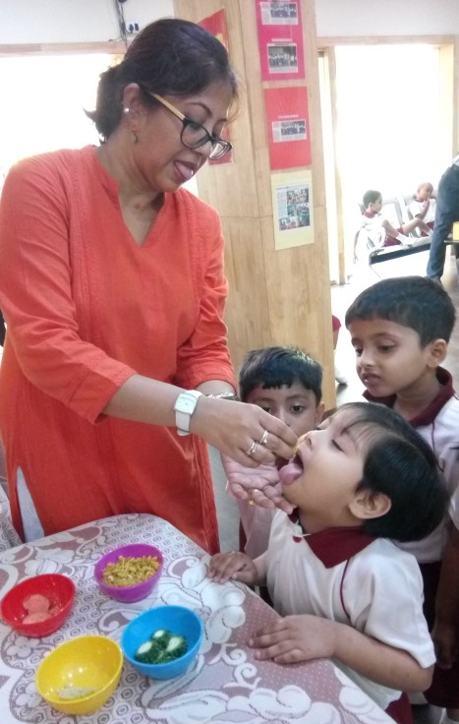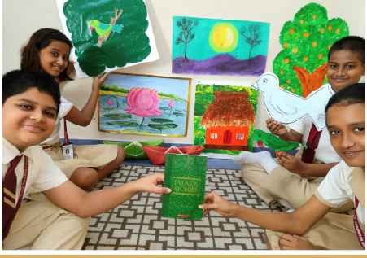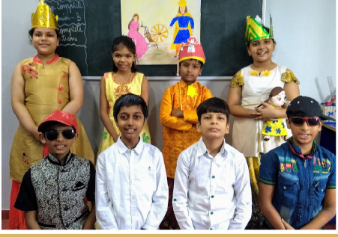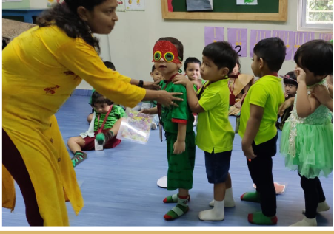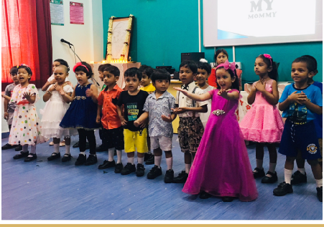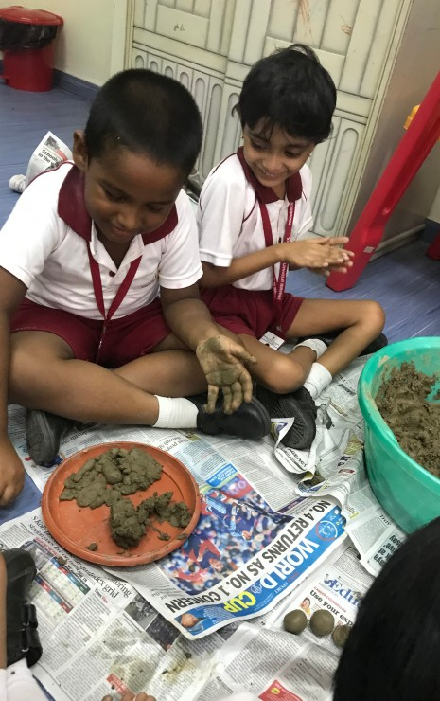

READING WEEK READING WEEK

SENSE STATION READING WEEK READING WEEK

PARENT ORIENTATION MOTHER’S DAY

TEACHERS’ DAY RABINDRA JAYANTI MUD DAY

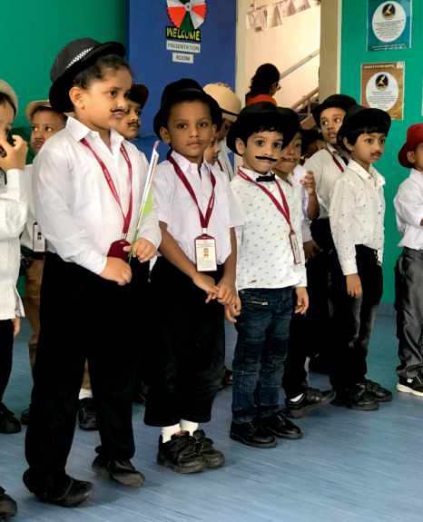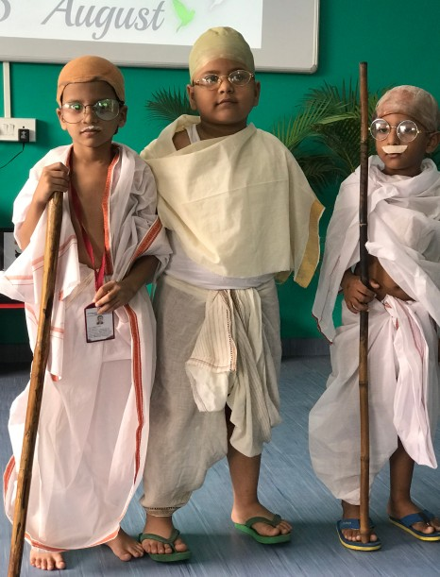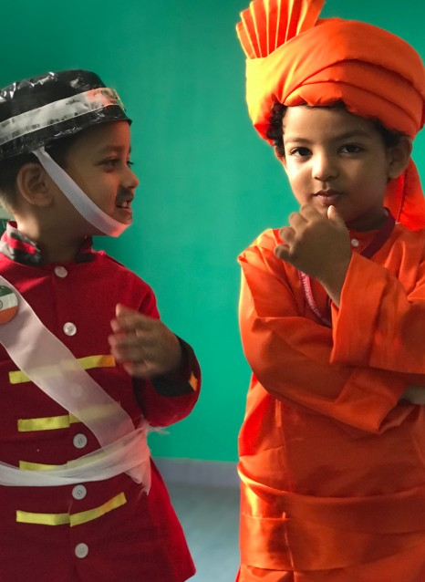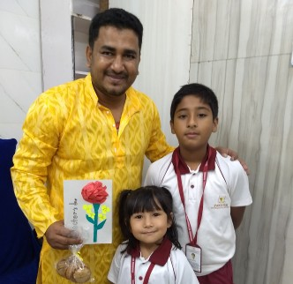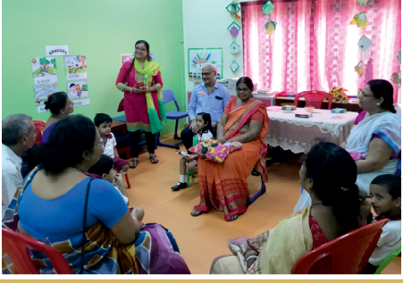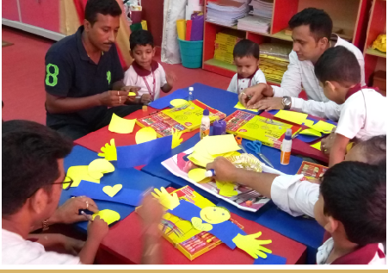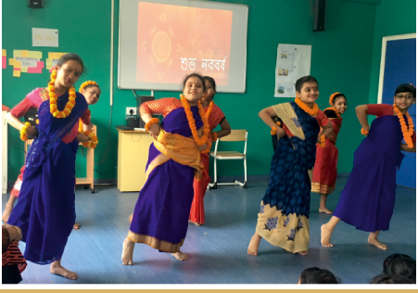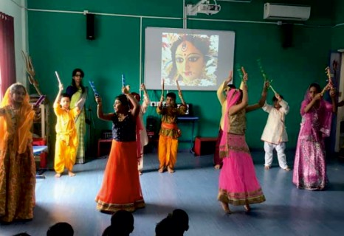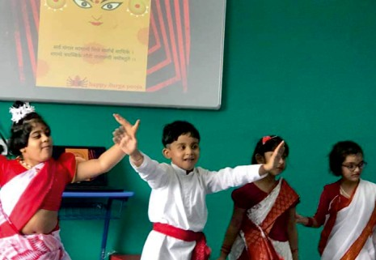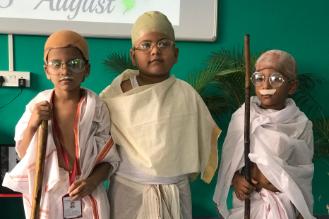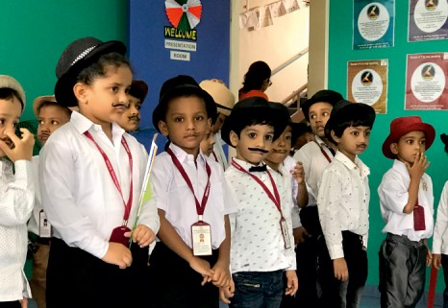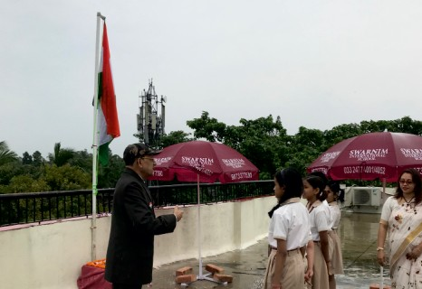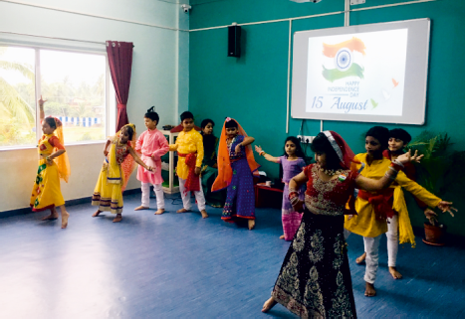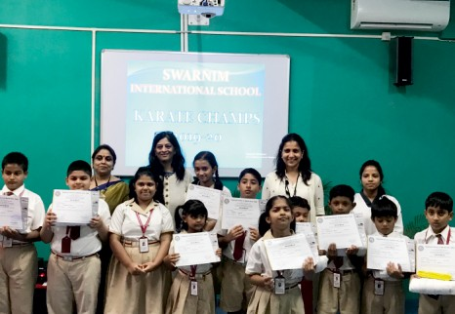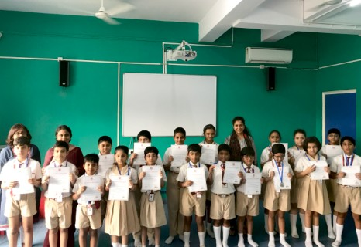HIGHLIGHT OF EVENTS
“The whole purpose of education is to turn mirrors into window”- Sydney J. Harris

GRANDPARENTS’ DAY FATHER’S DAY DOCTORS’ DAY

DURGA PUJA CELEBRATION BENGALI NEW YEAR

INDEPENDENCE DAY KARATE YELLOW BELT

KENKEN QUALIFIERS FOR NATIONAL LEVEL

FANCY DRESS
SWARNIM INTERNATIONAL SCHOOL
12 N. S. C. Bose Road, Kodalia, Kolkata 700 146
P: 0332477 4052/4001, +91 90733 77590 | W: www.swarniminternational.in | : /SwarnimInternationalSchool

