Tips To Manage Your Child's Anger Effectively

Source: Surabhi Kumar, Counseling Psychologist and Special Educator

ANGER is a healthy emotion. It is normal for adults and children to feel angry. But we are often taught to suppress or resist it. However, anger itself is not a negative emotion but the way it is expressed, is, at times unhealthy.

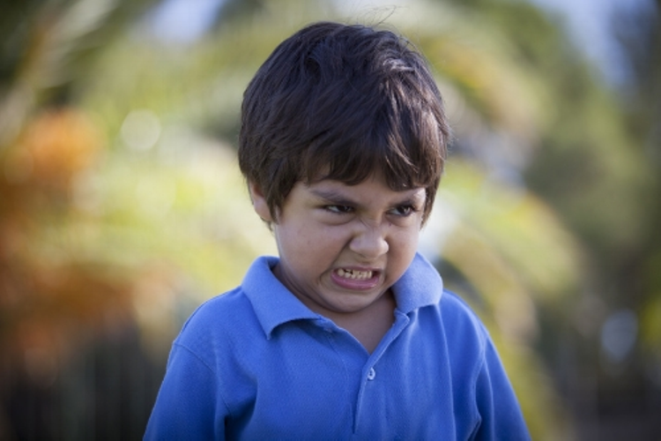
Like other emotions, children experience anger too. Since they are not taught to express it in a healthy way, Children often forget to differentiate between angry feelings and aggressive behaviour. Their anger and frustration turn into defiance, aggressive behaviour (violence) and temper tantrums. It’s our responsibility as adults to help them deal with their emotions and express them effectively. This can be done when we take adequate steps to help children manage their anger.

Label the Feelings- What are they feeling?
The most important step is labeling or giving a name to the feelings. At times, children feel frustrated or they are upset about something and they tend to behave aggressively. We need to speak to the child and find out what they are feeling whether it is sadness or frustration. If it leads to hitting and harming self or others, as a parent we can tell the child “It’s OK to feel (name of the feeling) but not to hit or harm others.

Explore the Feelings - Why are they feeling?
We need to help them find ‘why’ they are feeling angry. Talk to the child and help them verbalize their emotions. Often it is something that has happened at school or with friends that they are upset about. “The best gift you can give a child is your time”. Spend time with them, speak with them and help them search for the reason behind their feelings. Never tell a child that ‘it’s such a small thing why are you getting upset or angry about it?’ Because for you it might be ignorable but for him, it must be big that’s why it’s bothering him. Always get down to the child’s level to understand him.

Modelling Behaviour
We have a huge responsibility as parents or teachers because we are not just raising a child but building their future. If we lose our cool, children will observe and learn the same. Most of the times, they are observing us even when we are unaware of it. Hence, we must express anger in appropriate ways. At times parents ask me, ‘What can I do? I am not able to control my anger and we both lose it at the same time and this leads to hitting and screaming’. Parents, who have difficulty controlling their own anger, must walk away from the child when they are angry and come back when they are calmer.

Recognizing Triggers
Anger is a reaction. Every child is different and as parents, we are aware of the triggers that cause anger. If saying something to the child triggers anger, he screams when teased or if a child gets angry when he’s informed about last moment changes in his schedule-for instance, suddenly having a class during playtime when there was none, one should refrain from doing that. In this case, try to work around things so you can avoid a meltdown later.

Considering Others Feelings
If the child has hurt someone else in anger, teach him to apologize to the other child. They should be explained that it’s important to consider others’ feelings and it’s not ok to hurt others. The child could apologize verbally or make a card or do the way he would like to do it.
Coping Skills
To manage any emotion, we need to develop effective coping strategies. A particular strategy might not work for all the kids. Some might want to be hugged when angry, some want to be left alone (always under parental observation), some would want to draw and some count backwards or shout for a moment or take few deep breaths depending on their age. Talk to the child when he is calmer and ready to speak with you.

Positive Feedback
When a child displays coping skills or expresses anger in a healthy way, always appreciate the child. Positive feedback will help the child understand that he has managed his feelings well and hence, there will be higher chances of displaying that behaviour in the future. Management of anger is a skill. To raise emotionally healthy adults, we need to start teaching this skill from childhood. Learning is a process that involves trial and error and hence kids will respond differently to the coping techniques. It’s our aim to patiently help them find out what works best for them and contribute towards their emotional wellbeing. Always let the child know that you love him in spite of his anger and help him manage his feelings.
If the strategies do not work for your child or if his anger always turns into violence, it is best to seek professional help from a Psychologist who would find out any underlying cause for the behaviour and guide you to develop a behaviour management plan.

