Preventing Neck Strain in Kids During Online Classes
Source: Dr. Disha Nayak, M.P.T, Prenatal and Postnatal wellness Expert and a Health Blogger
Schools were forced to shift to online classes because of lockdown from late March. Education has changed dramatically for them, with the distinctive rise of e-learning, whereby teaching is undertaken remotely and on digital platforms. As a result, complexities that ordinarily would be considered for such a shift may not have been given much early thought.
But now, the excessive use of different mobile and computer applications for these classes is throwing up a new range of issues. Many parents have been consulting for their children having neck pain, back pain etc. Although businesses have been involved in setting up ergonomically correct workplaces for their employees, students doing online education from home are asked to sit at a regular desk and use devices without thought being given to strain on their necks, shoulders, back & eyes.
I am sharing some ergonomic tips to set school at home for E-Learning:
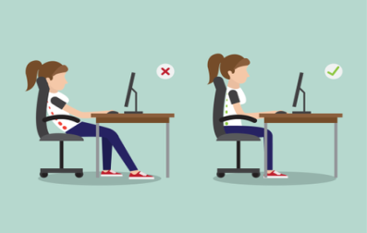
- Arrange a proper study area with a proper desk and chair, which allow your child to sit straight with back support instead of leaning forward.
- Keep small stool underneath the chair your child sits in so that he or she sit with proper alignment rather than feet handing in air.
- Ensure that the computer or laptop screen is at eye level. Give the laptop a base or place it on top of a surface so the laptop screen sits at the eye level of your child. Adjusting the height of your monitor according to the eye or head level is just as important.
- Make sure that if your child wears eyeglasses, they are an appropriate fit so that head doesn’t lean forward when you look at your screen.
- To avoid neck strain, use your eyes for proper alignment according to your line of vision.
- Encourage your child to sit straight, maintaining vertical alignment of the ears, shoulders, and waist.
- Tell your child to stand up and stretch every 20 to 45 minutes and also blink intermittently.
- Decrease the TV time and involve your child more in play activities.
Here are some exercises and play options for your child to help with the neck & shoulder strain:
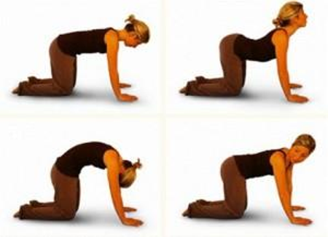
- Cat Camel Pose: Ask the child to come on all limbs like a cat. Start like a cat: Sink the back down towards the floor and lift your head up at the same time and arch the lower back curve. Take a big breath out at the same time. Then become a camel: Tuck your head in trying to touch the chest and tailbone in, arching through your spine similar to the camel. Take a big breath in at the same time.
- Ball throwing and catching
- Skipping
- Neck rotations and stretching
- Chin Tuck: Tuck or slide the chin inward such that it touches the back of the neck. Avoid blocking your chin down to the chest.
- Shrugging: Raised your shoulder slowly such that it touches the ears. Hold that position for about 15 to 20 seconds. Bring your shoulders down slowly as it relaxes.
- Suryanamaskar: Surya Namaskar is a great warm-up for kids, as it stretches the entire body and helps move every joint and major muscle group present.
- Football
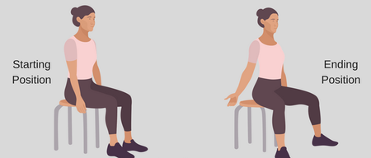
- Bruegger's Position: Perform these at an interval of an hour or so every day. You can do these either standing or sitting. Sit or stand up straight. Rotate your shoulders starting from the back and going down while squeezing the shoulder blade. Stretch your elbows, fingers, and wrists as far as you can behind your arms. Push your chest out and arching your upper back. Movement should be on your middle back, not on your lower back or torso. Hold this position for 30 seconds and relax

We hope these exercises help your kids and you.

