Books To Help Kids Enjoy & Understand The Rain Better!
Source: Janani S Koushik, Content Writer & Former Systems Engineer at TCS
Oh, the smell of garam pakodas and corn! The monsoons are here and how! The southern and western parts of the country are luckily receiving a good amount of rainfall (if not great) and that's got all of us to do the happy dance! As much as I am paranoid about the monsoon and the illness that it brings along, we do ensure that our kid experiences the first drops of the season- the typical joys of childhood!
Also head to Summer Fun Factory for age-wise book lists for kids.

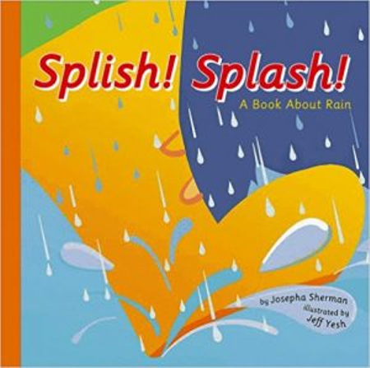
- Splish! Splash! A Book About Rain
Age: 5-9 years
Author: Josepha Sherman
What this book tells your kids: This is not a story book, but explains the processes involved in rains, water cycle, droughts and floods to the little minds that can think. Can be classified as a science book or a non-fiction book or a bed time book that inspires your kids to think. Buy the book here.

- Rain Rain Go Away
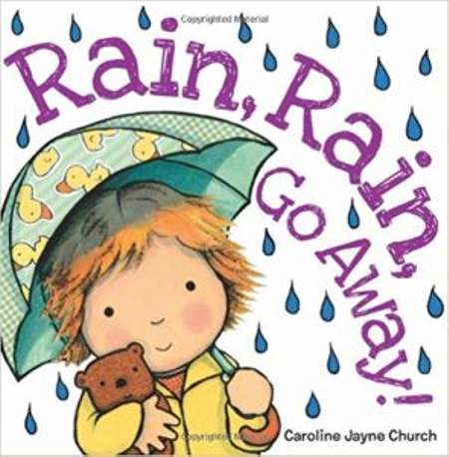
Age: 3-5 years
Author: Caroline Jayne Church
What this book tells your kids: This one is for the li'l readers in your house! The book is based on the widely popular rhyme that goes by the same name and is complemented by adorable pictures that your kids will love. Relive the joys of childhood with this book.

- Dinosaur Thunder
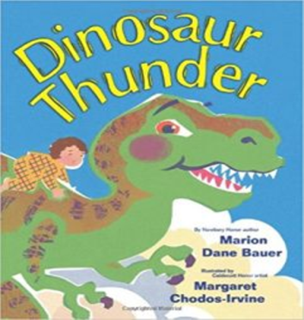
Age: 3- 5 years
Author: Marion Dane Bauer
What this book tells your kids: Little kids and puppies are alike- they are both scared of rains and storms, right? Here's the story of a little boy who is extremely scared of storms and there's nothing that can calm him except one. What's that? Find out.
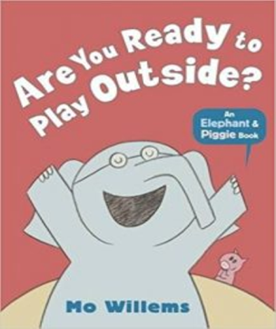
- Are You Ready to Play Outside?
Age: 5 years and above
Author: Mo Willems
What this book tells your kids: How much excited can get a few drops of rain make you? Gerald, the elephant and Piggie the pig are best buds and their joy knows no bounds when they hear the first pitter patter raindrops. Add this to your Mo Willems collection- we are sure your kids will love it as much as we did.

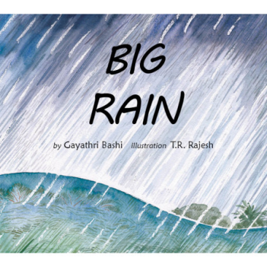
- Big Rain
Age: 6 years and above
Author: Gayeties Bashi
What this book tells your kids: Rain is fun and something that kids will love. But how do you explain "lots and lots of rain" to a 3-year-old? This author makes use of an engaging narrative to explain to her 3-year-old about the recent Kerala floods and why rains, are not always welcome, especially when they come in a whole new, frightening format.

- The Little Rainmaker
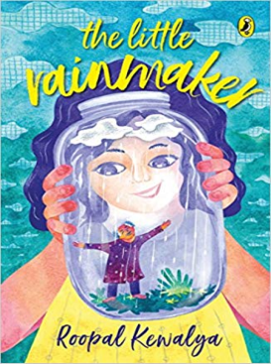
Age: 8 years and above
Author: Roopal Kewalya
What this book tells your kids: How would it be to live a life where you haven't witnessed rain at all? Little Anoushqa lives in a city where she hasn't witnessed what it means to have even the slightest rainfall. How does she then believe her Grandpa's tales of thunderstorms and floods? How does he go about chasing the impossible to fulfil her grandfather's wish?

Happy Reading!

