Montessori Principles That Help Improve Your Child's Playtime

Source: Ana Kapur, Product Marketing Lead & Brand Manager, Parenting Blogger and a Mother
Montessori is a way of raising children based on observing the child, giving them freedom in an environment created to suit them and enabling them to master their environment by learning practical life skills.

Principle #1: Use Open-Ended Toys
Open-ended toys are toys that can be played with in many different ways. For example -balls, blocks, dolls, scarves (or old dupattas), animal figures, vehicles, art materials. These are the toys we played with as kids. These can be repurposed into myriad different things during play. The toys foster imagination, spark a child’s creativity and last a child much longer. Basic pretend-play starts in kids as early as 18 months, peaks at 3-4 years and can last up to 6 years old.
Strengthen the Principle: Toy – Rotation
Have you seen your toddlers pick up one toy, and then drop it for the next – distracted among all the options available and not really playing with anything in particular? What has helped us tackle this superbly is the simple concept of toy rotation. Display a few toys at a time and rotate them periodically. With my 6month old, I use 3 toys a day with daily rotation and I’ve seen her eyes light up when she sees something reappear after a few days. For a toddler, weekly rotation of 6-10 toys works well.

Principle #2: Encourage Practical Life Activities
Have you seen your child show more interest in a spoon, a stool, or some random household object than a toy you gifted them? Around 15 months old, once kids have mastered the use of their hands and feet, they are driven to master their environment next. This means curiosity – and naughtiness.
Directing this energy into practical daily life activities such as setting the table, watering the plants, captures kids’ imaginations and builds confidence as they learn to do things for themselves. Plus, they can tag along with you as you go about your work at home.

Strengthen the Principle: Breaking an Activity into Steps
Before you introduce a practical life activity to your child, do it yourself consciously. Become aware of the steps it involves – and then break it into steps. Even if your child cannot do an activity completely, they can do some steps in it. If they cannot yet tie their shoelaces, they can cross their laces while you make the bow. If they cannot bake a pizza, they can place the cut vegetables on the pizza base. Breaking an activity into steps and letting them do the steps that they can set them on the path to learning the entire activity.

Principle #3: Observation
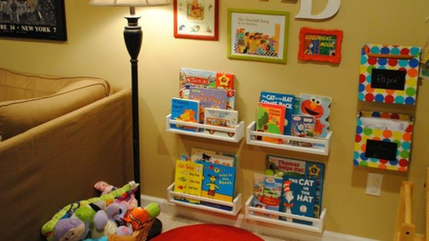
Observing what a child is doing and tailoring the activities you provide for them is one of the cornerstones on the Montessori philosophy. Ms Montessori said, “Leave the child alone and watch what she does. Do not abandon her, but watch from a distance. You can get to her if she needs help. To give children freedom and be watchful and ready to help is not easy, but we must be prepared to do all this.” Really, curb your urge to “play with” the child, and let her free to explore. You’ll be amazed to see what she does.

Strengthen the Principle: Create a Self-Serve Play Area
Do you let your infant play on your bed, and then pull them away from the edges saying, “Don’t go there”? Are you often running behind your toddler pulling them away from something, saying, and “don’t do that”? Montessori believes these constant corrections hinder a child’s confidence and curb their curiosity. Instead, we should create child-friendly areas around the house, for e.g. a play area in the bedroom, a reading corner in the living room. The child should be free to play and explore in these zones, without your help or guidance. Things that they are supposed to play with should be accessible at their height, and things that are not safe for them should be kept out of reach. Such a self-serve area fosters learning and independent play.
Try the basic principles and build on them as your child feels comfortable. After all, Montessori isn’t about one-size-fits-all; but about adapting the activities for your child.

