Finding your Smile

Source: Sam’s Blog

In schools all around the country, life carries on as normally as possible. The children learn, the teachers teach, and we’re all wearing extra layers to combat the cooler temperatures of keeping all our windows and doors open for extra ventilation. Undercutting all of this is a constant, vague unease and uncertainty. How safe is everyone? The figures the health department gives us suggest that transmission amongst younger children is very low indeed and so far we have all been fine. But we’re all aware that it only takes one or two undetected cases for a whole staff of adults to potentially be infected so we’re aware there are, of course, risks. And we’re not just worried about getting it ourselves but also about passing it on to others who might be more vulnerable to its symptoms.
Carrying on as normal does help to keep the worry demons at bay but I think most of us at some point have spells of weariness and anxiety. We keep an upbeat manner but sometimes, underneath, there’s that nagging sadness or fed-up-ness that tries to escape. For the last week or so, I’ve felt very much that way and, when presented with the task of preparing my weekly (filmed) assembly, I just didn’t know what to talk about. For the first time in a long time, I felt uninspired. Ideas flitted in and out of my mind and I couldn’t settle on anything. As the days passed and the deadline loomed, I began to panic.
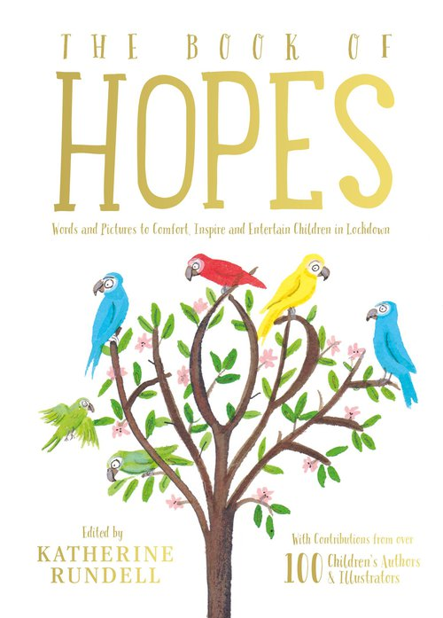
I told the children that I had gone through a spell of feeling uninspired and that I had, as librarians do I guess, gone to a bookshop for inspiration. I still couldn’t find anything that leapt out at me to talk about but I did buy some lovely books for the library and, lo and behold, I found a hook!The book that provided it was, suitably, The Book of Hopes – a collection of short stories, essays, poems and illustrations by children’s writers and illustrators.
Local author and academic Katherine Rundell (The Explorer, The Good Thieves, Rooftoppers, etc) is the editor and she pulled the book together during our first Lockdown to help provide some hope and happiness for families in a time that looked quite dark.
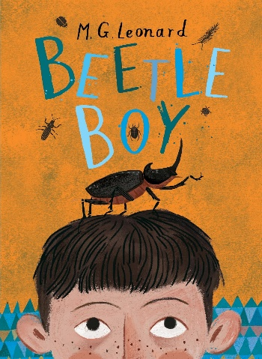
There are many interesting pieces in the book but the one I chose was a short essay on dung beetles by MG Leonard, who wrote the BeetleBoy series, the first of which I am currently reading to Year 4. We are really enjoying it!
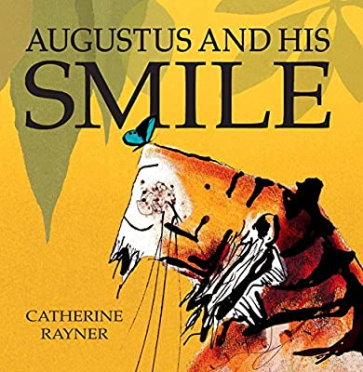
Suffice it to say I was completely amazed at the relatively humble dung beetle. Yes, it does live life for something we find particularly disgusting, but it’s an amazing creature. It can push/drag fifty times its own body weight (to us, it’s the equivalent of pulling six double-decker buses full of people), it cares for its offspring as part of a devoted couple and some mate for life. I think what inspired me was the fact that by doing something quite normal for it, it does something pretty amazing. Small things can be quite incredible, can’t they? We don’t need to look very far or long for something to admire.
Next, I read the story of Augustus and His Smile, by Catherine Rayner.
This book features poor Augustus, a tiger who just can’t find his smile – very much how I felt on Monday! So he goes off in search of it and eventually finds it in his own reflection. Along the way, he experiences the everyday joys of life and, if you look carefully, you can see his smile grow bigger on each page. Again, Augustus realises that we don’t have to look far to find beauty and happiness, even in the most challenging of times. The book certainly put a smile on my face, not just through the quiet message but through the stunning paintings throughout. Catherine Rayner’s books really are an artistic treasure.
To finish, I played the children the song ‘Don’t Worry, Be Happy’, by Bob Marley. Reggae always has that relaxed, happy feel to it and it felt like the perfect tune to lift someone’s spirit. As I listened, I couldn’t help but feel calmer and more reassured. Times might be tough but if we have good books to read and look at, happy music to listen to, and friends to talk to, we can get through this.
I hope if you are feeling down in the dumps that this post helps. You’re never alone.

